

**CI/CD Configuration with Jenkins   
within Kubernetes Ecosystem**

**Version History**

|  |  |  |  |  |  |
| --- | --- | --- | --- | --- | --- |
| SI | Date | Ver | Description | Changed by | Approved/Reviewed by |
| 01 | 02-Oct-21 | 1.0 | CI/CD Configuration with Jenkins  within Kubernetes Ecosystem | Maidul Islam  Software Engineer | Md. Mahedee Hasan  Head of Software Development |

Contents

Introduction 3

Installation Requirements 3

Environment Setup 4

Configure Jenkins Node 5

Step 1: Configure Host name, Hosts file and define a static IP address 5

Step 2: Installation of OpenSSH-Server 7

Step 3: Turn Off Swap Space 7

Step 4: Install Java 8

Install Jenkins 9

Step 1: Install and Configure Jenkins 9

Step 2: Fetch Default Jenkins Password 12

Step 3: Customize Jenkins and install necessary plugin 13

Step 4: Configure Login Credentials 14

Install “SSH Pipeline Steps” Plugin 16

Install MSBuild plugin 18

Install Docker on Jenkins Node 19

Step 1: Install Docker.io 19

Step 2: Add Current User to Docker Group 19

Step 3: Add Jenkins User to Docker Group 20

Dotnet setup and Configuration 21

Step 1: Install .NET 21

Step 2: Install .Net SDK 21

Jenkins Pipeline Script 22

Step 1: Create Jenkins Pipeline 22

Step 2: Store GIT Credentials 23

Step 3: Clone the Git Repositories 25

Step 4: Script for Dotnet and build 27

Step 5: Build Docker image and tag it 29

Step 6: Store Docker Hub Credentials 30

Step 7: Docker Login via CLI 31

Step 8: Push Docker Image into DockerHub 32

Step 9: SSH into AMSL-Master Node 34

Step 10: Deployment and Service 35

Step 11: Copy program-deployment-service.yaml to AMSL-Master server 36

Step 12: Create kubernetes deployment and service 37

Step 13: Complete Script for CI/CD pipelines Jenkins 38

Verify Deployment 40

Activate Automatic Jenkins Build 41

Add Unit Test 42

Test Automation 43

Step 1: Update YAML File 43

Step 2: Update Jenkins Pipeline script 45

Conclusion 48

References 48

# Introduction

Continuous integration (CI) and continuous delivery (CD) are the processes that are used to build, package, and deploy an application. Basically, it lays out some practices to follow in order for the code developer writes to more quickly and safely get to users and ultimately generate value.

A CI/CD pipeline is a path for delivering a unit of change that starts from development to delivery. It helps developers to automate steps in software delivery process and allows application development teams to release software quickly.

# Installation Requirements

In this document, I am going to describe the procedure of installation and configuration of CI/CD pipeline with Jenkins on Virtual Machine and configure within kubernetes ecosystem. I have used VMWare Workstation but you can choose any VM according to your preference.

System requirements

1. Disk size - 20gb
2. Memory - 4gb
3. Number of processor core – 4

We are going to update Hostname and hosts, static IP and Hosts on Virtual Machine during configuration.

We are going to configure Virtual Machine for Jenkins with below Hostname and static IP addresses.

|  |  |  |
| --- | --- | --- |
|  | **Host Name** | **IP Address** |
| **Jenkins-Server** | amsl-jenkins | 192.168.254.9 |

# Environment Setup

Create a virtual machine with above configuration in VMware.

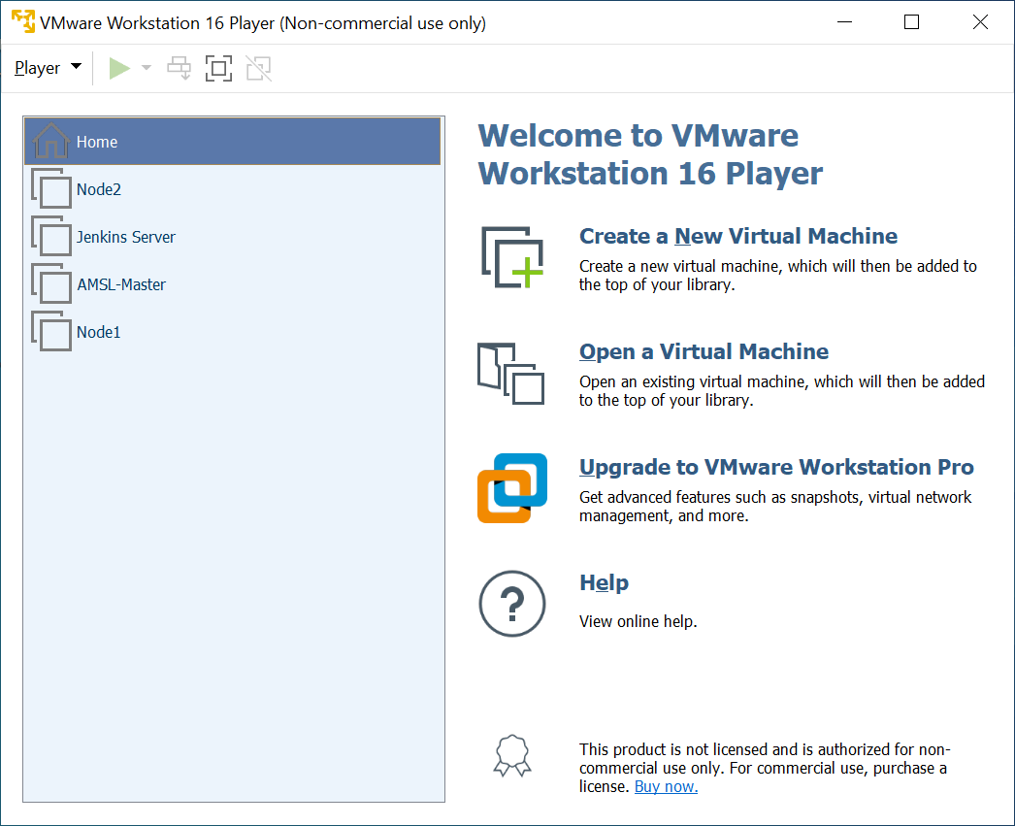

I have used **ubuntu-21.04-desktop-amd64.iso** to configure Jenkins OS.

# Configure Jenkins Node

## Step 1: Configure Host name, Hosts file and define a static IP address

1. Login into Jenkins VM and open Terminal.
2. Write below command to update the host name.

sudo nano /etc/hostname

A text editor will open and update the name to amsl-jenkins and save and exit.

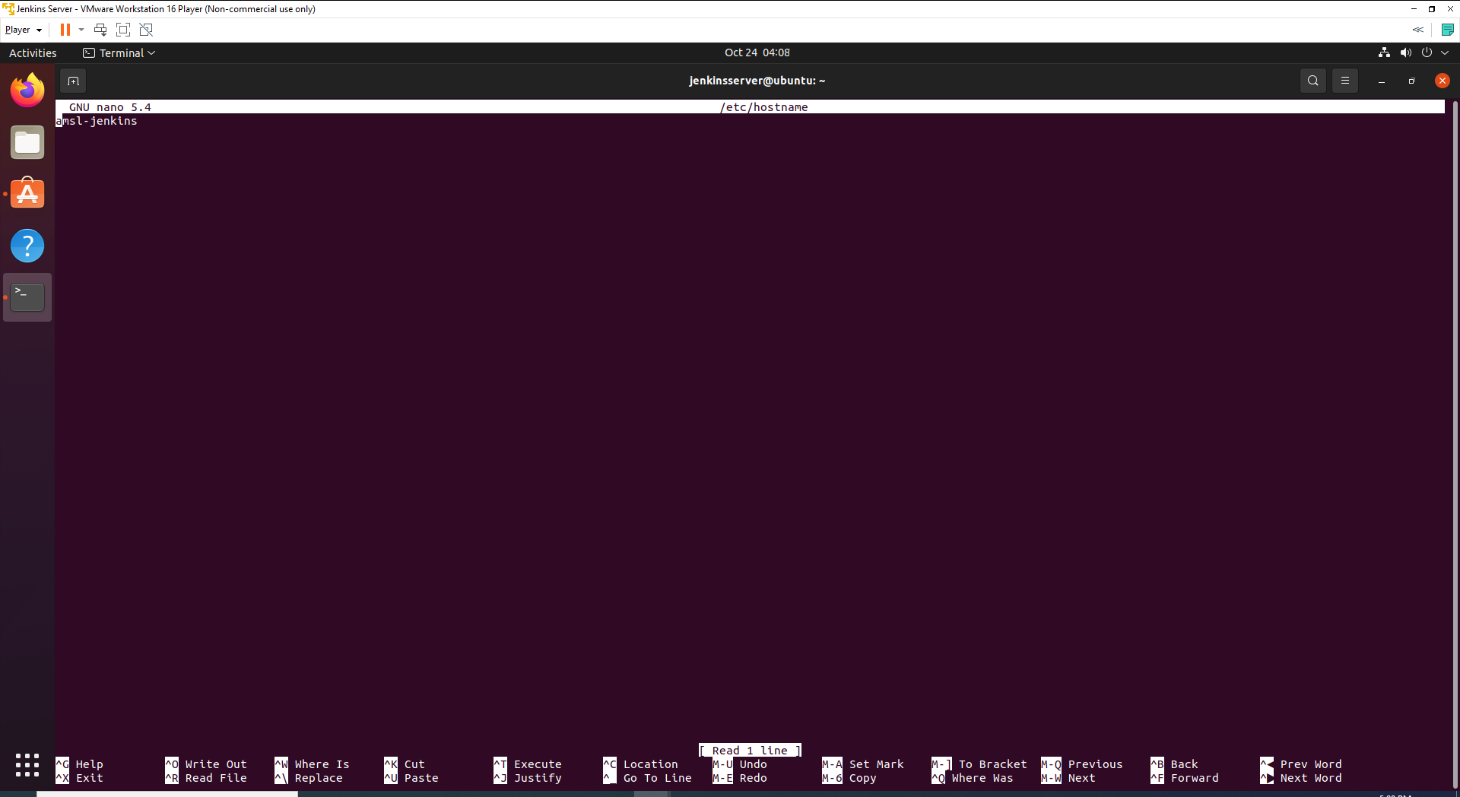

1. Write below command to identify the name of the Ethernet interface.

ip link

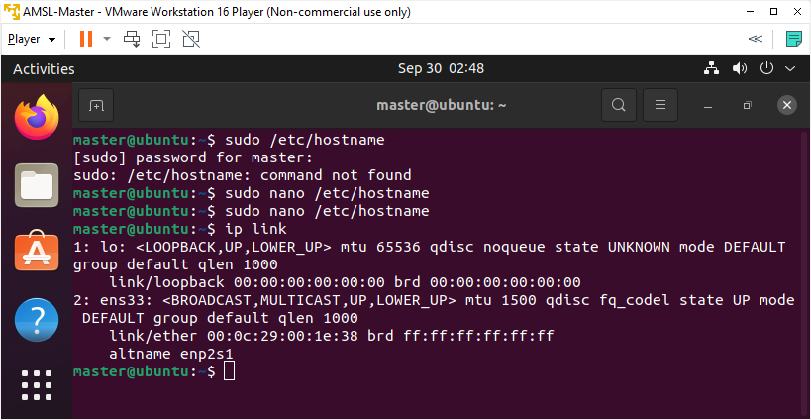

As we can see that our Ethernet interface name is ens33.

1. To assign a static IP address on the network interface, open the YAML configuration file with a text editor with below command.

sudo nano /etc/netplan/01-network-manager-all.yaml

1. Update the page with below code.

network:

version: 2

renderer: NetworkManager

ethernets:

ens33:

dhcp4: false

addresses: [192.168.254.9/16]

gateway4: 192.168.254.2

nameservers:

addresses: [192.168.254.2,8.8.8.8]

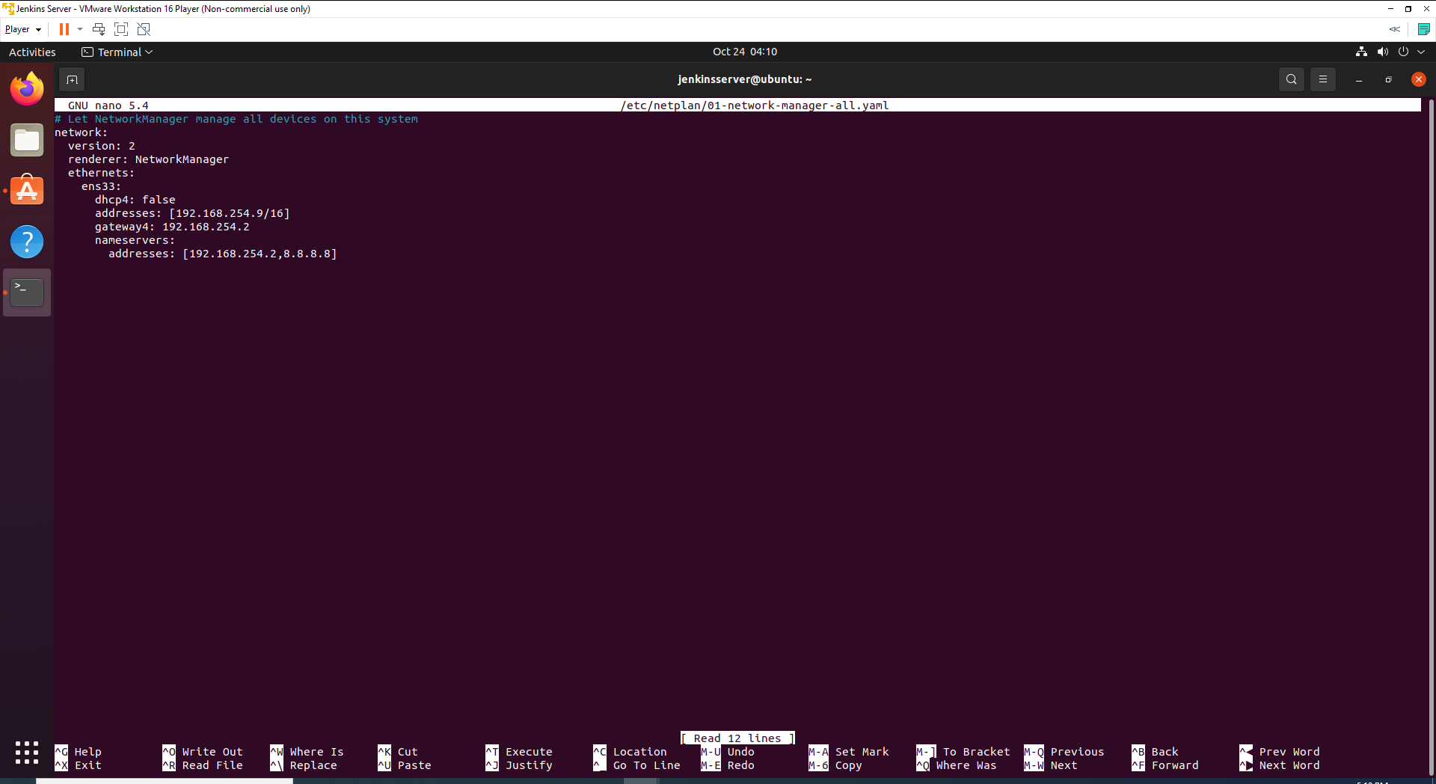

1. Save and exit.
2. Apply the changes by running the following command.

**NOTE: Update Gateway according to your own network gateway, otherwise network not going to work.**

sudo netplan apply

1. Now we are going to update hosts file, as we have decided earlier about the host name and IP addresses of Jenkins Node. Write below command to open the hosts editor.

sudo nano /etc/hosts

1. Hosts file includes name to IP mappings for VMs. Update the page with below text.

192.168.254.9 amsl-jenkins

192.168.254.10 amsl-master

* + - 1. amsl-n1

192.168.254.12 amsl-n2

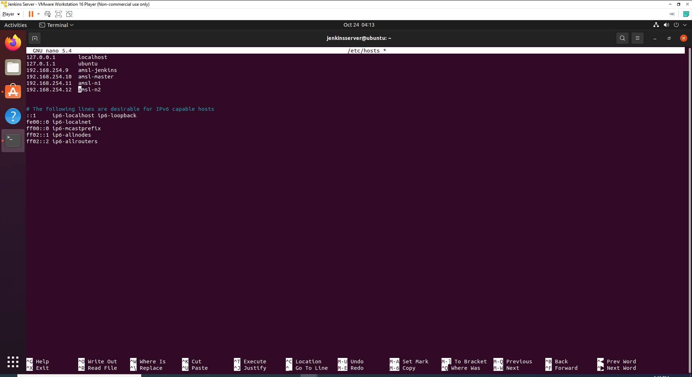

1. We need to include Jenkins nodes host name and IP Address inside Master and workers nodes as well. Update **hosts** file of Master and Workers nodes.

## Step 2: Installation of OpenSSH-Server

Now we have to install openshh-server. Run the following command:

sudo apt-get install openssh-server

## Step 3: Turn Off Swap Space

1. We need disable swap before we start doing any other process. Write below command to swapoff.

sudo swapoff -a

1. Open fstab file and delete or comment swap line as below, I have commented the swapfile line. Write below command to open fstab file.

sudo nano /etc/fstab

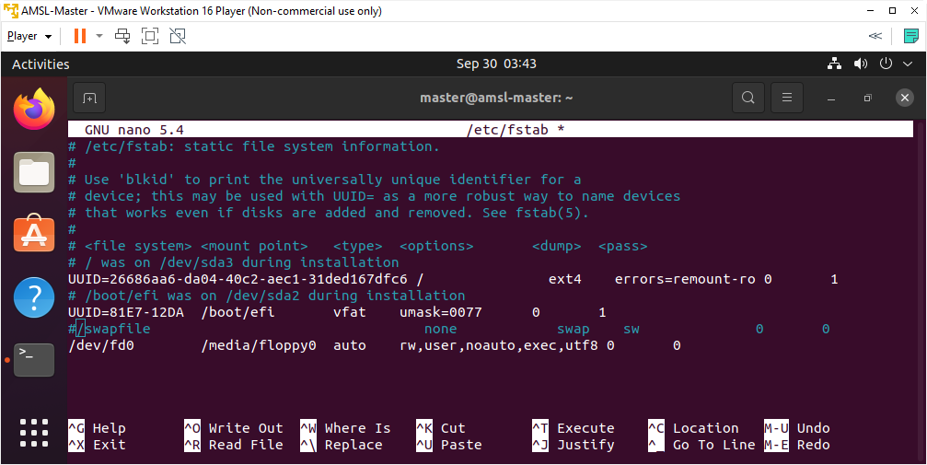

1. Save & exit.
2. Reboot the system.

## Step 4: Install Java

Java is necessary to configure and install Jenkins.

1. Update the repositories of your ubuntu -

sudo apt update

1. Install Java with below command.

sudo apt-get install openjdk-11-jdk

1. Verify your java installation by running the following command

java -version

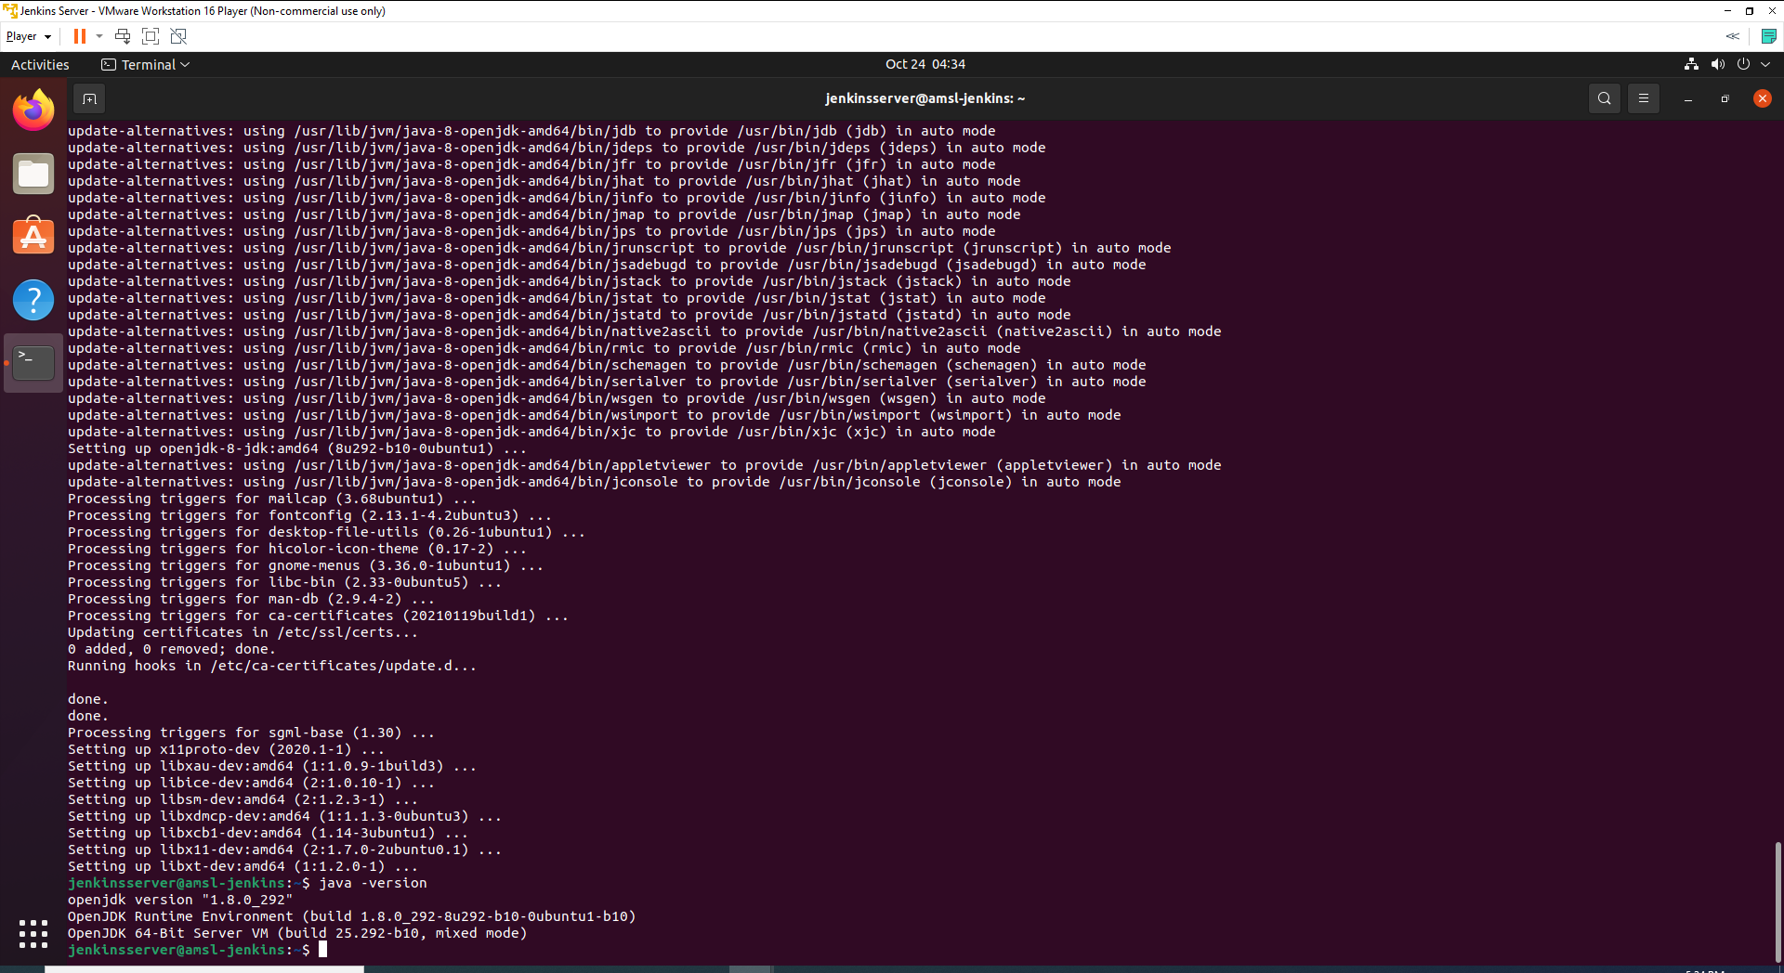

# Install Jenkins

## Step 1: Install and Configure Jenkins

1. Now we can install the jenkins on our Ubuntu OS, use the following command to install.

wget -q -O - https://pkg.jenkins.io/debian-stable/jenkins.io.key | sudo apt-key add -

sudo sh -c 'echo deb https://pkg.jenkins.io/debian-stable binary/ > \

/etc/apt/sources.list.d/jenkins.list'

sudo apt-get update

sudo apt-get install jenkins

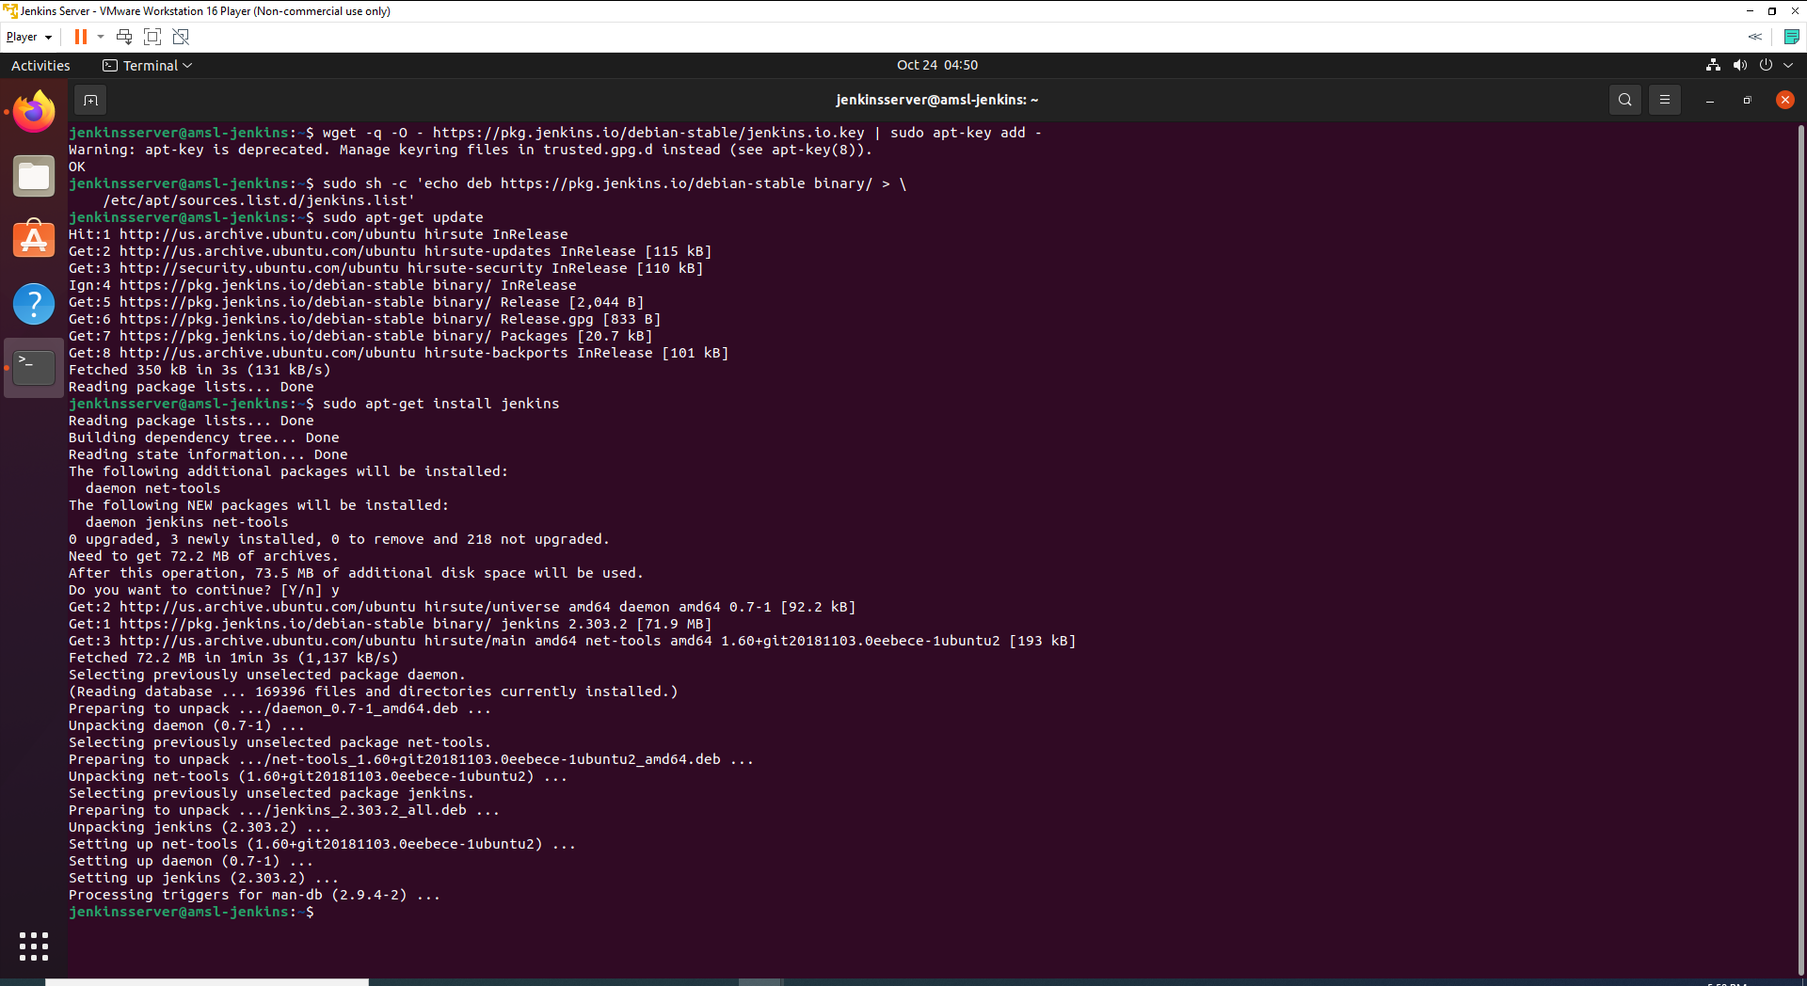

1. Now we are going to verify if Jenkins installed in the system with below command.

sudo systemctl status jenkins

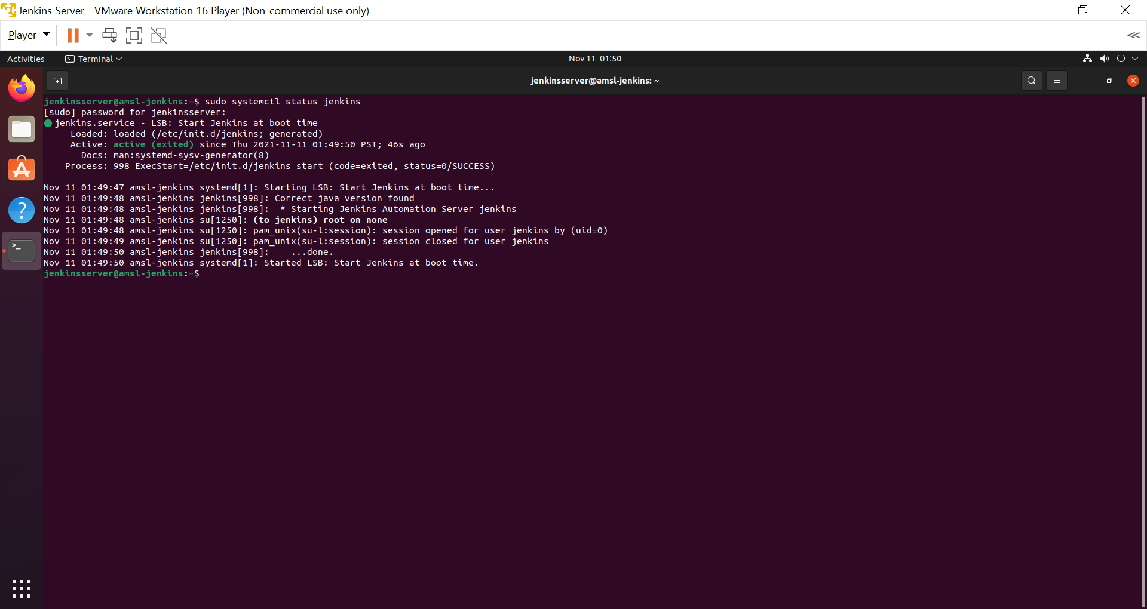

1. As we have installed Jenkins, now we can check on browser. Visit <http://192.168.254.9:8080/> or if you have defined different IP address and port, please try with your URL and port number. Browser will display a login page like below.

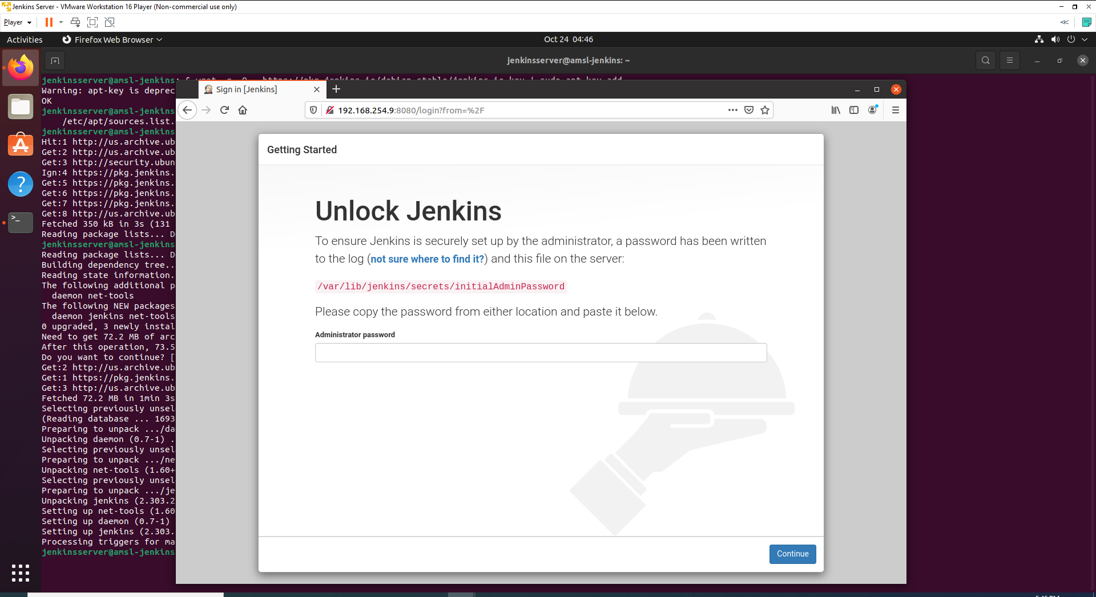

## Step 2: Fetch Default Jenkins Password

Now we are going to fetch default Jenkins password and this password also called default Jenkins password. There are multiple ways to retrieve password.

1. Using the Jenkins Logs file located at - /var/log/jenkins/jenkins.log. Run the following command.

cat /var/log/jenkins/jenkins.log

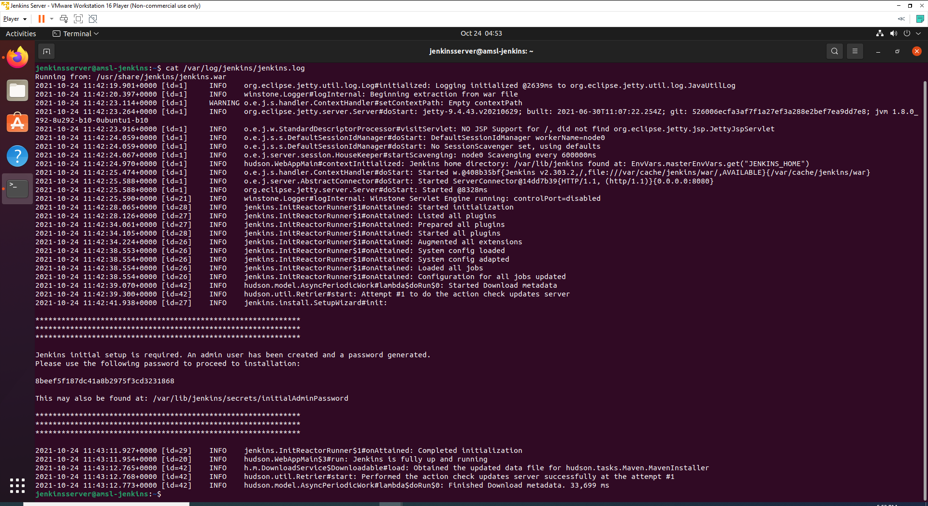

Now you can copy generated password and paste on Administrator Password textbox on Jenkins landing page on web browser.

1. Another way of retrieving password with below command.

sudo cat /var/lib/jenkins/secrets/initialAdminPassword

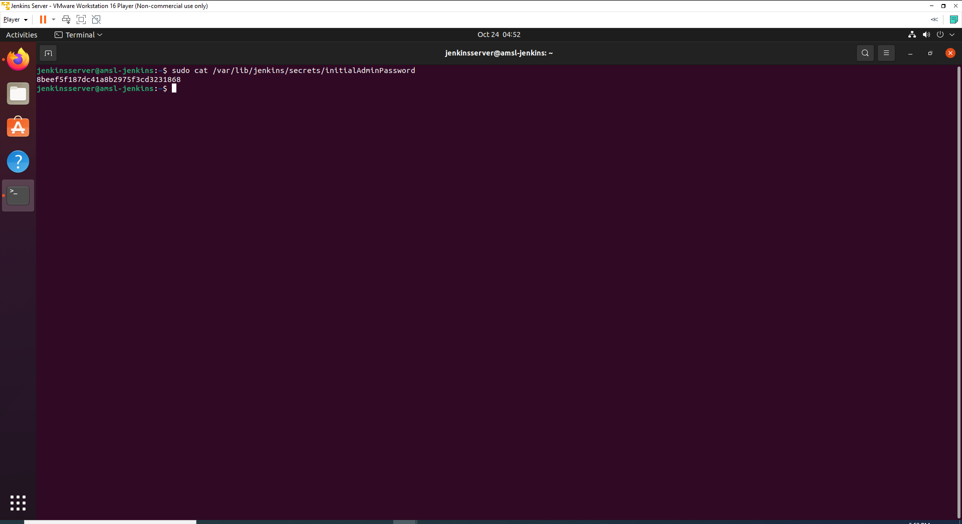

Now you can copy generated password and paste on Administrator Password textbox on Jenkins landing page on web browser.

## Step 3: Customize Jenkins and install necessary plugin

Following page going to be viewed after you have entered your initial Admin Password.

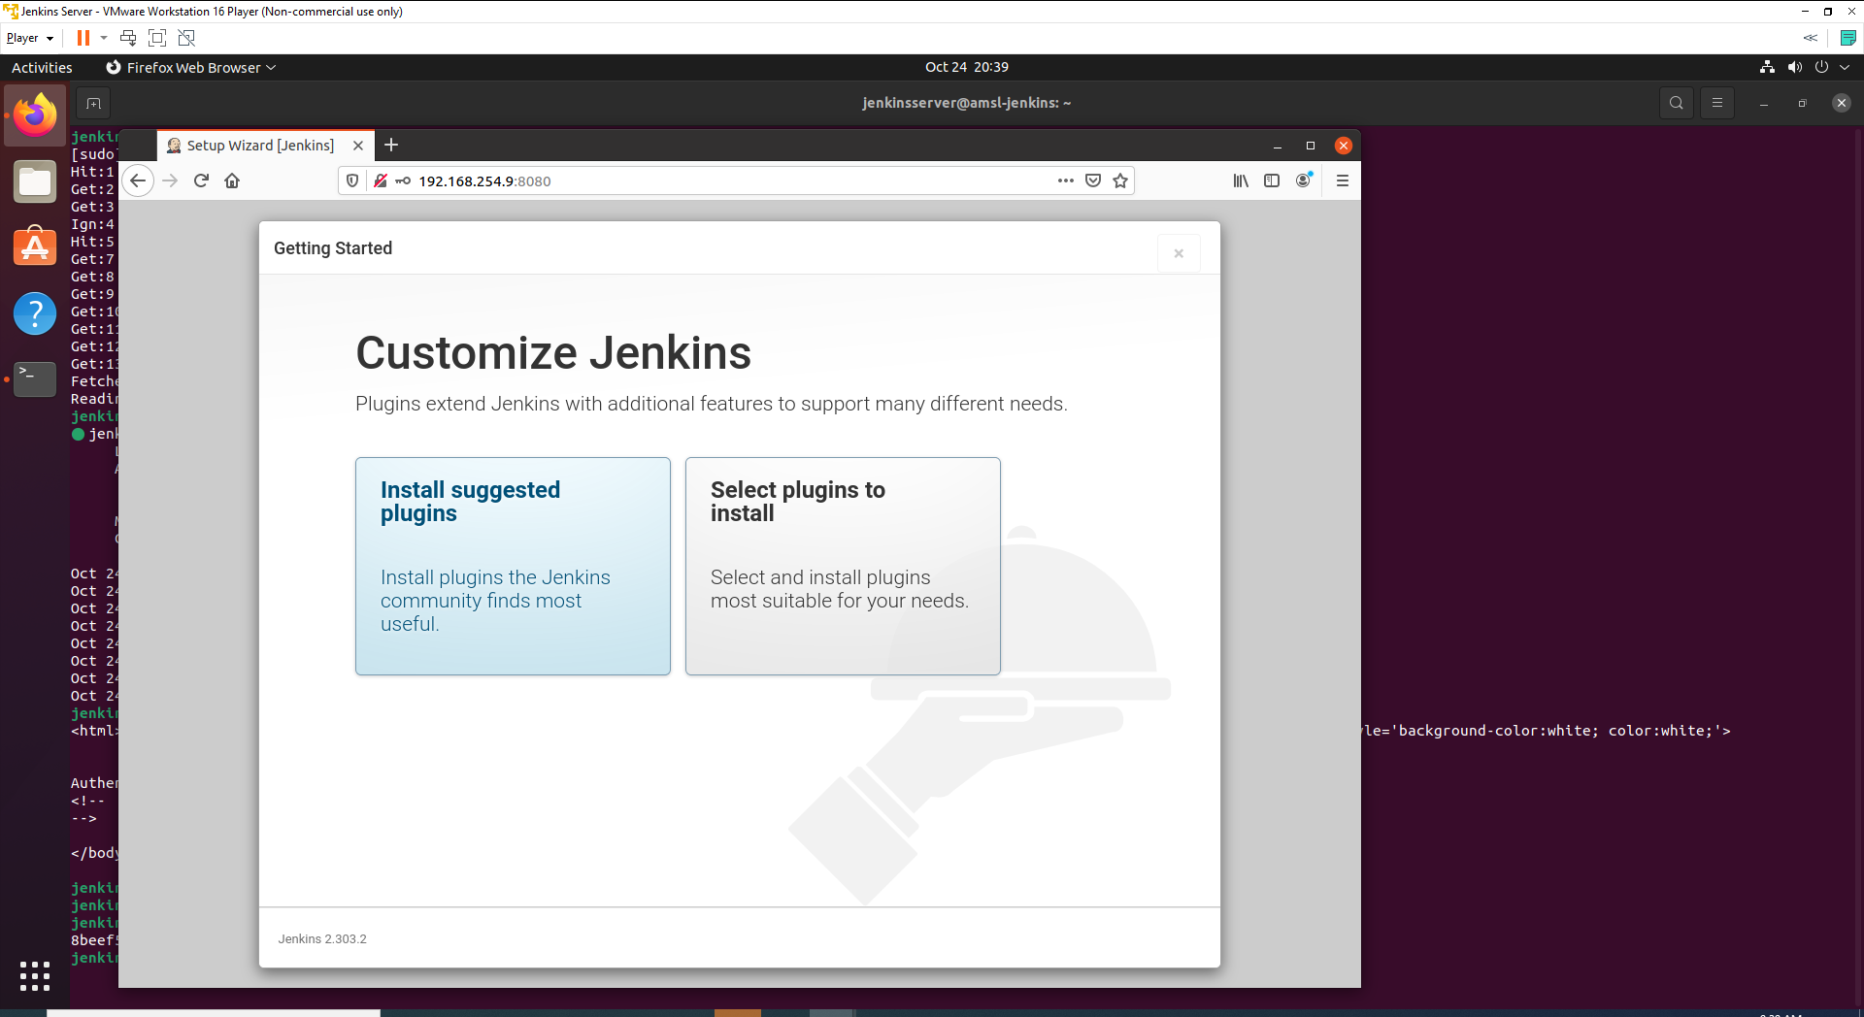

Select install suggested plugins and it will start install necessary default plugins.

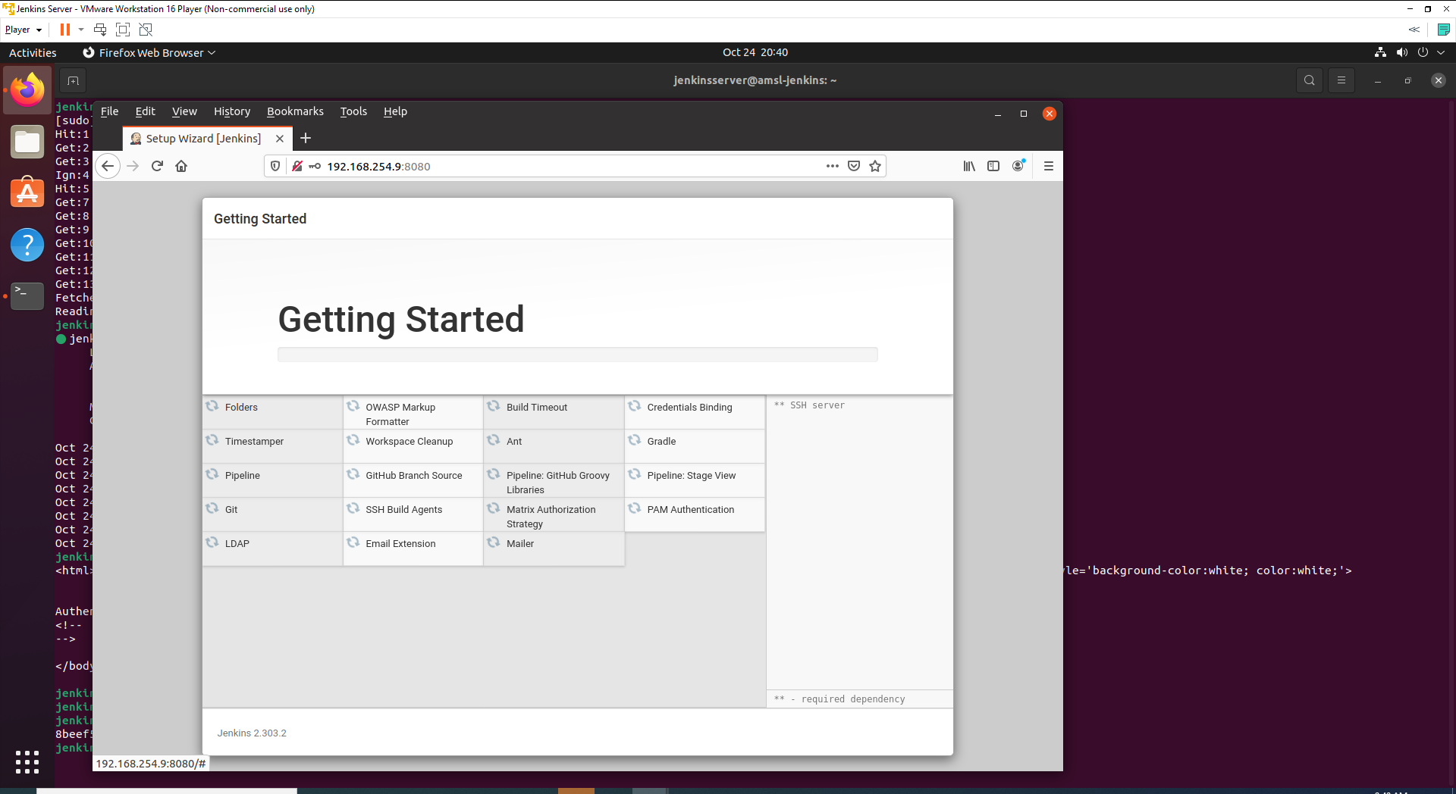

## Step 4: Configure Login Credentials

After installed all the suggested default plugins, a page will be prompted for setting up username and password.

1. Set a username and password. Please set a desired a user name and password.

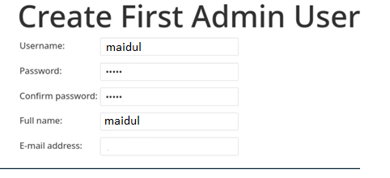

1. Now it will ask for Jenkins URL and keep the default one (IP address should be same as machine IP address).

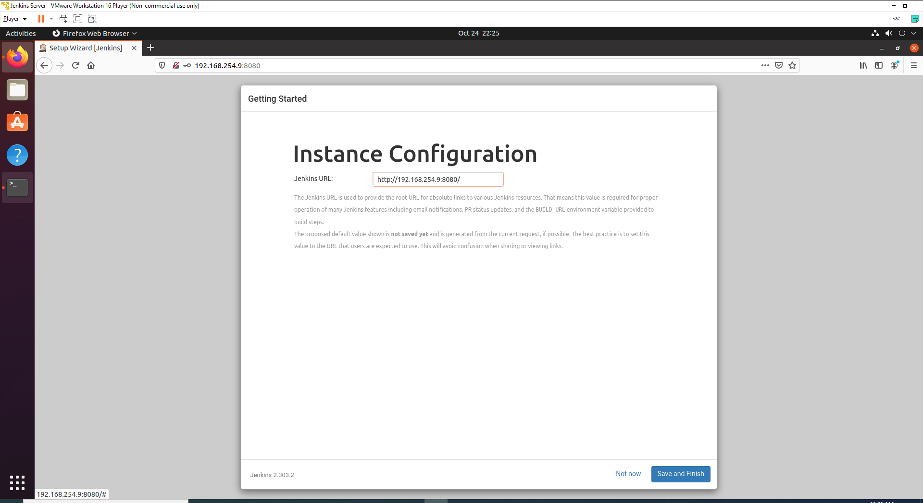

1. Click Save and Finish. Following display will show.

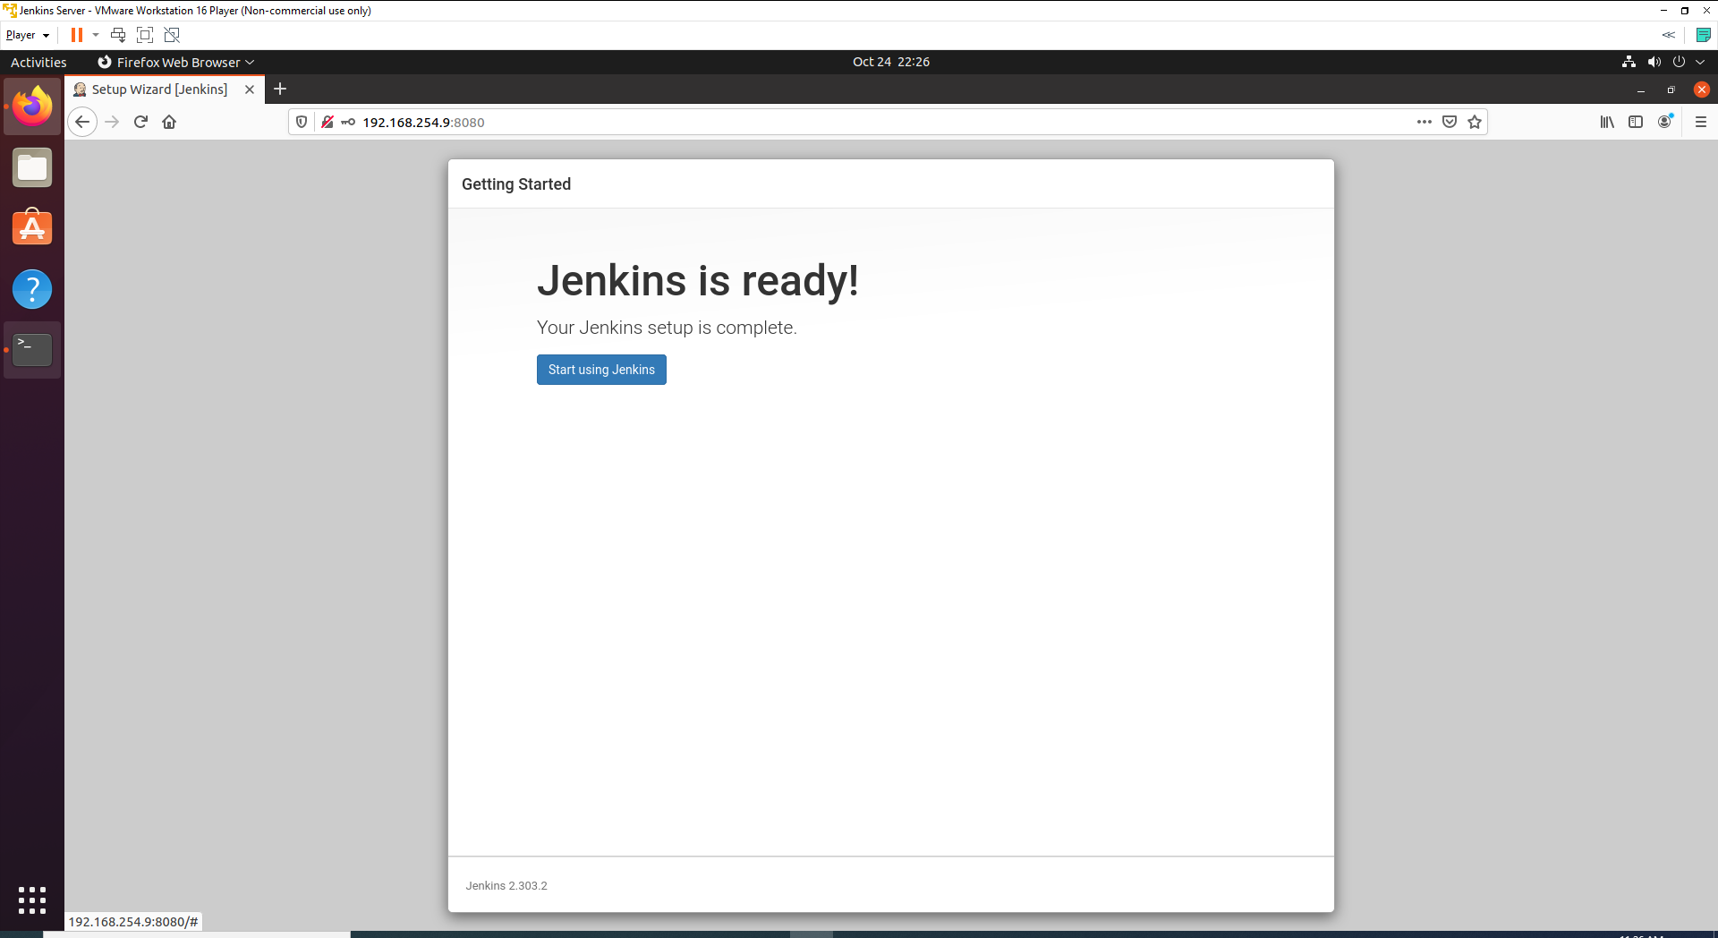

Click start using Jenkins. It will to take little time to redirect to dashboard.

You going to see a dashboard like below.

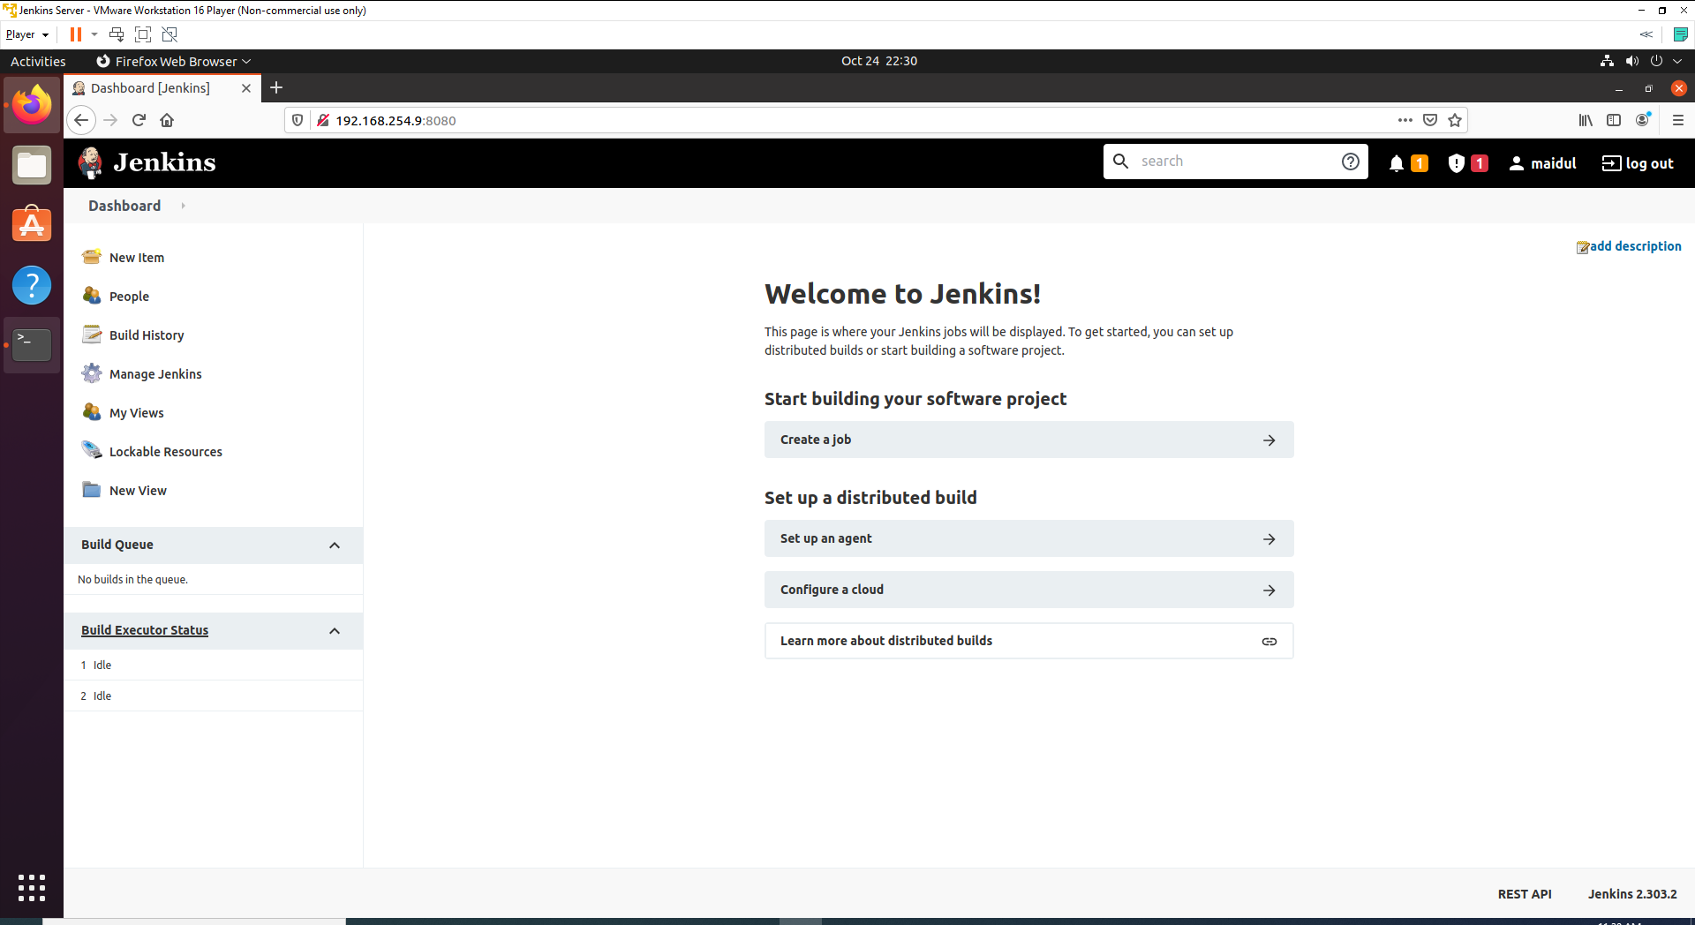

# Install “SSH Pipeline Steps” Plugin

We need to install one more plugin SSH Pipeline Steps and we are going to use for SSH into amsl-master, Node 1 and Node2.

1. For installing plugin please go to - Manage Jenkins -> Manage Plugin -> Available then in the search box type “SSH Pipeline Steps”.

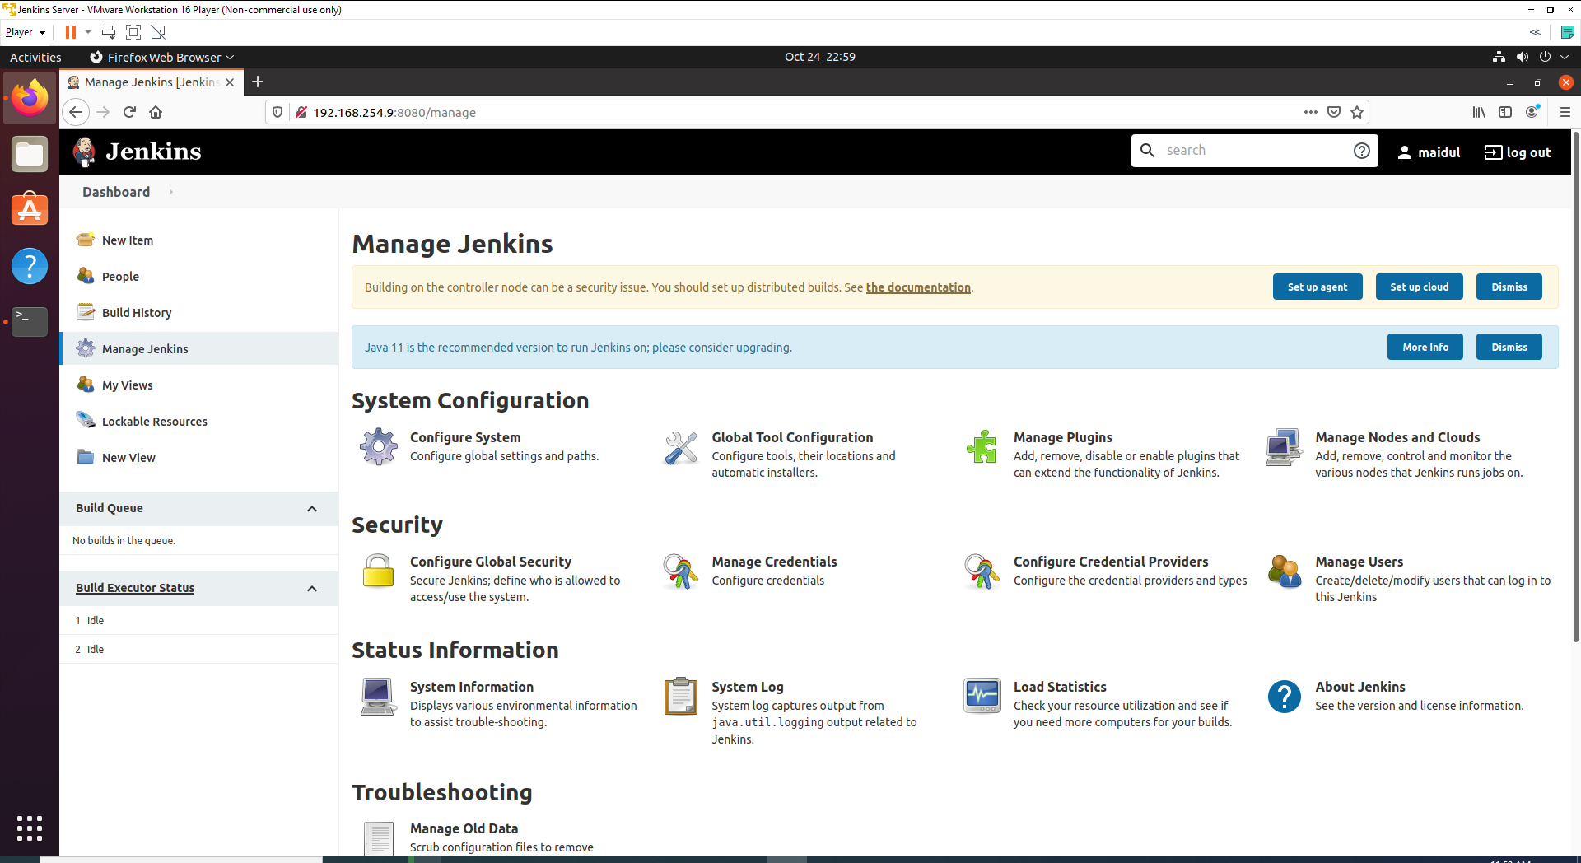

1. Select the plugin and install it without restart.

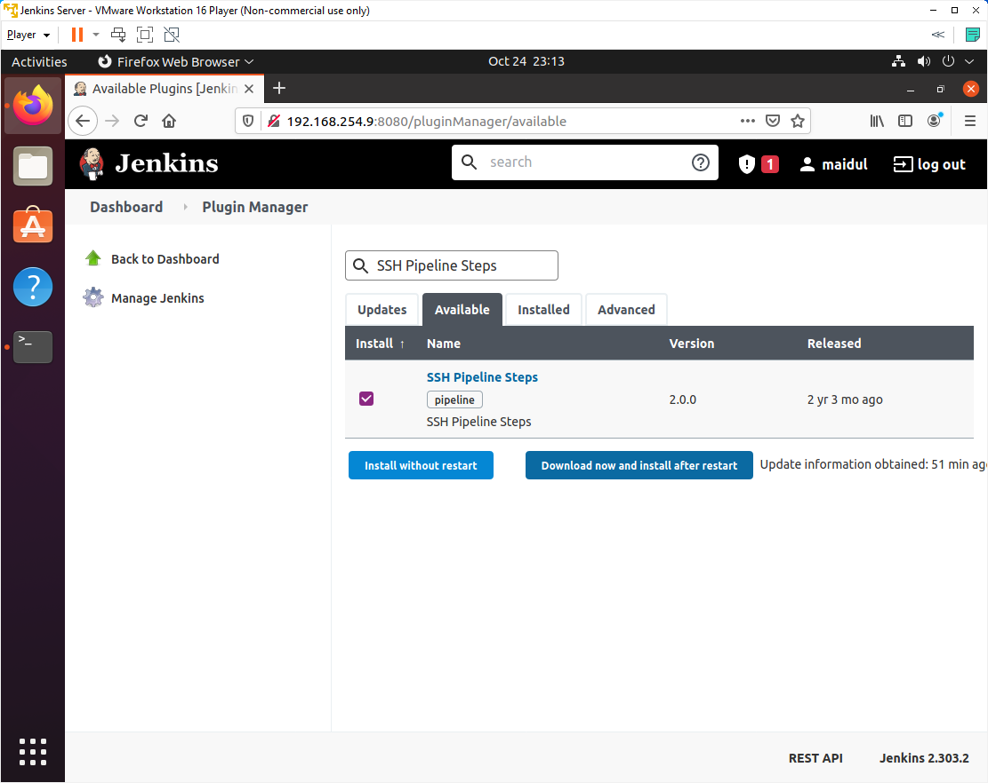

1. You will see a display like below after complete the installation.

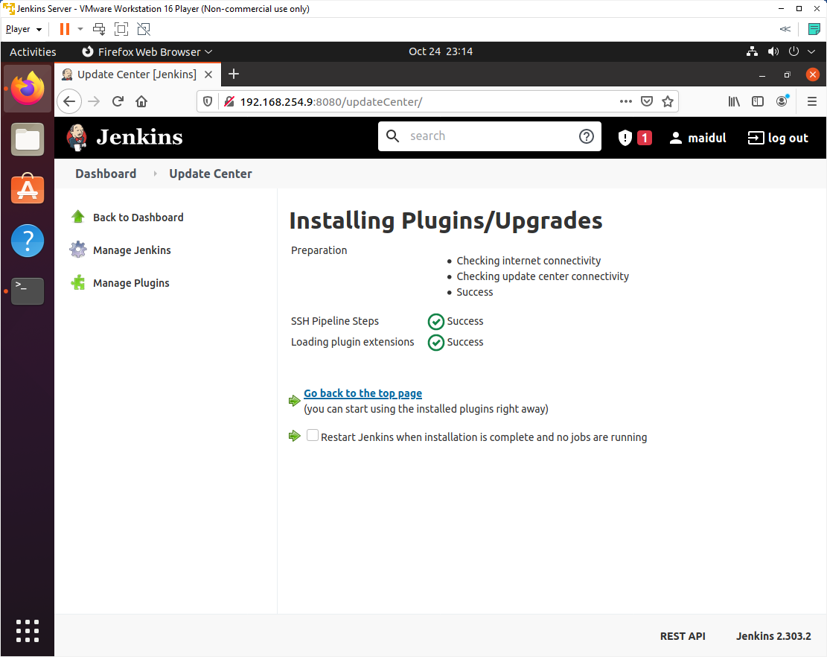

# Install MSBuild plugin

Now we are going to install MSBuild as our build tool.

1. To setup MSBuild Go to - Manage Jenkins -> Global Tool Configuration -> MSBuild
2. Click on Add MSBuild and then enter name **default**.
3. After that click on the checkbox - Install Automatically.
4. Refer to the following screenshot.

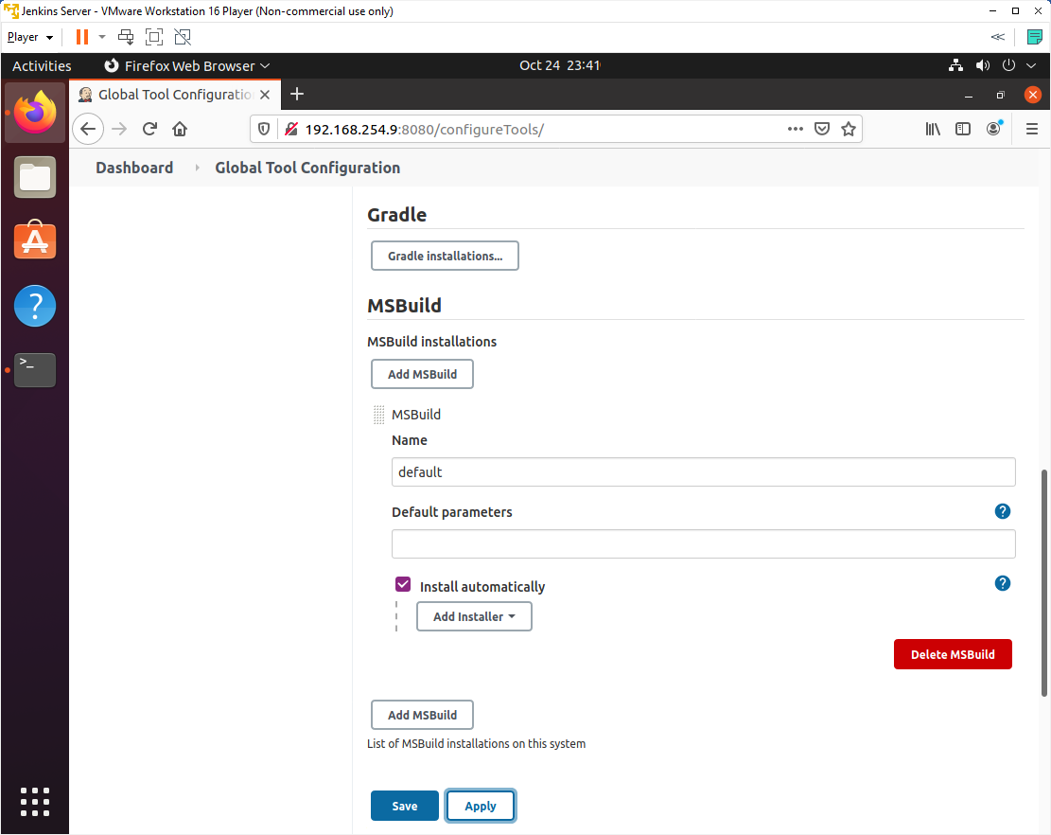

# Install Docker on Jenkins Node

## Step 1: Install Docker.io

Now we need to install Docker on Jenkins Node since we need to push our Docker image to DockerHub.

Open terminal window and use the following command to install the Docker -

sudo apt install docker.io

After installing docker verify the installation with following docker command –

docker version

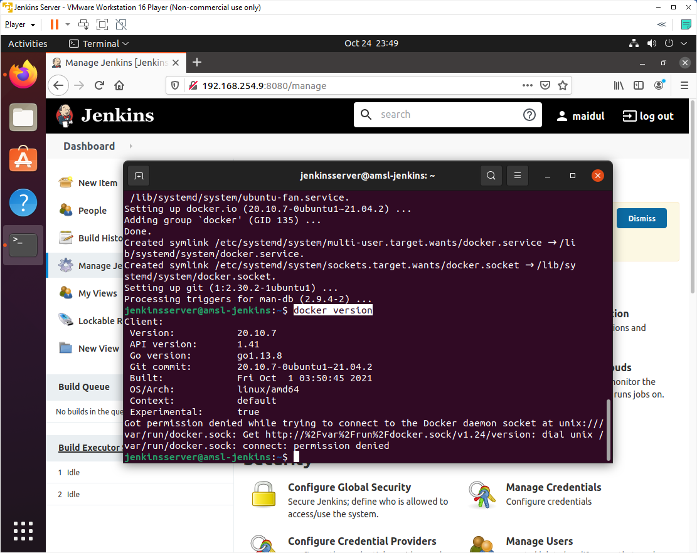

You might get a permission denied error like above with the details of version. Please follow following steps to solve above issue.

## Step 2: Add Current User to Docker Group

The next step you need to do is to add the current user to Docker Group to avoid the error - Got permission denied while trying to connect to the Docker daemon socket at unix:///var/run/docker.sock

Use the following command for adding current user to Docker Group.

sudo usermod -aG docker $USER

reboot

now try with below command again you will see the difference.

docker version

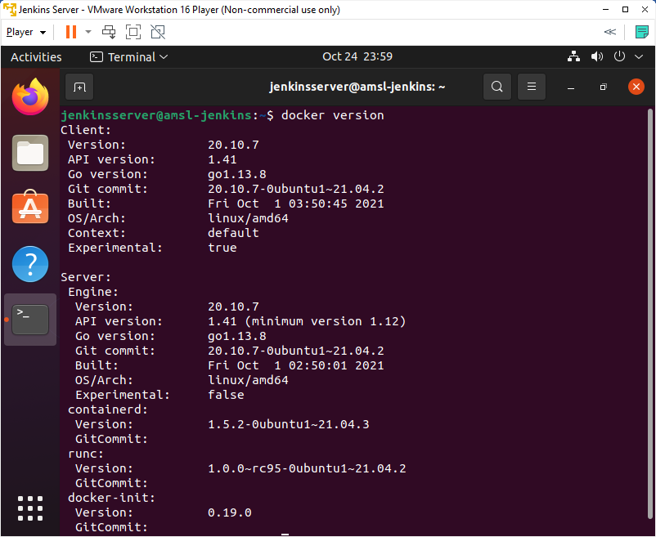

## Step 3: Add Jenkins User to Docker Group

Similar to previous step we also need to add Jenkins User to Docker Group, so that Jenkins can use Docker for building and pusing the docker images.

Run the following command to add Jenkins user to Docker Group.

sudo usermod -aG docker jenkins

reboot

# Dotnet setup and Configuration

## Step 1: Install .NET

Installing with APT can be done with a few commands. Before you install .NET, run the following commands to add the Microsoft package signing key to your list of trusted keys and add the package repository.

1. Open a terminal and run the following commands.

wget https://packages.microsoft.com/config/ubuntu/21.04/packages-microsoft-prod.deb -O packages-microsoft-prod.deb

sudo dpkg -i packages-microsoft-prod.deb

rm packages-microsoft-prod.deb

## Step 2: Install .Net SDK

The .NET SDK allows you to develop apps with .NET. If you install the .NET SDK, you don't need to install the corresponding runtime. To install the .NET SDK, run the following commands:

sudo apt-get update; \

sudo apt-get install -y apt-transport-https && \

sudo apt-get update && \

sudo apt-get install -y dotnet-sdk-5.0

# Jenkins Pipeline Script

## Step 1: Create Jenkins Pipeline

Now we are going to create Jenkins pipeline. Entire process we are going to resolve with Jenkins pipeline script.

1. Go to Jenkins -> New Items

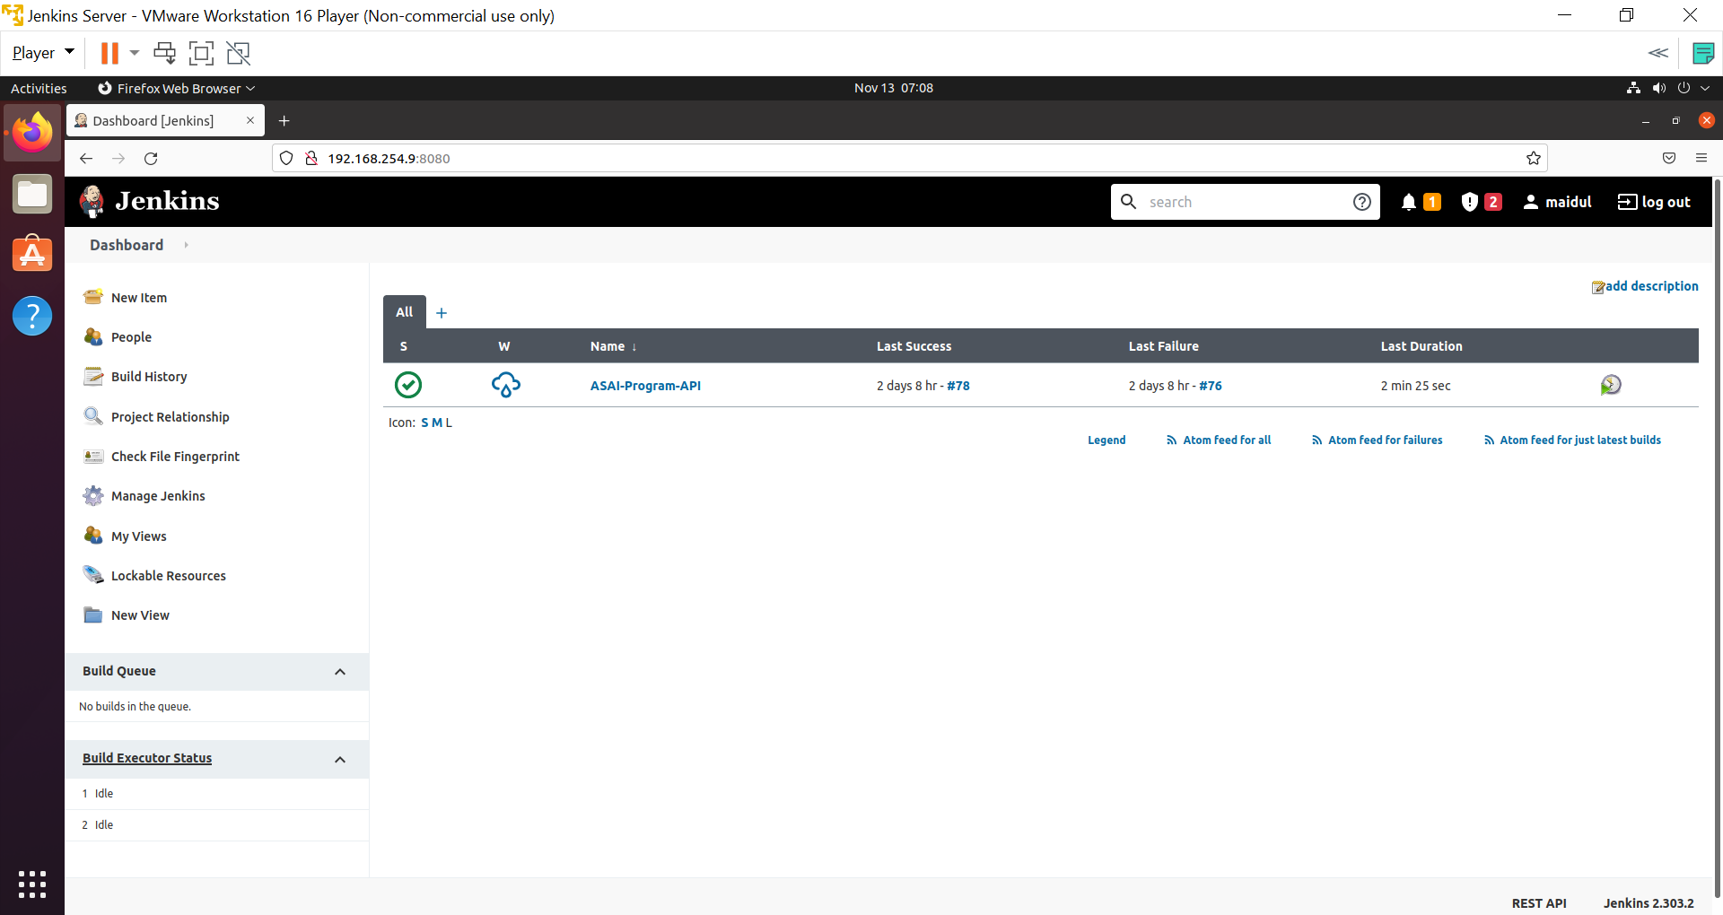

1. Enter an item name : **ASAI-Program-API.**
2. Select Pipeline.
3. Click Ok.

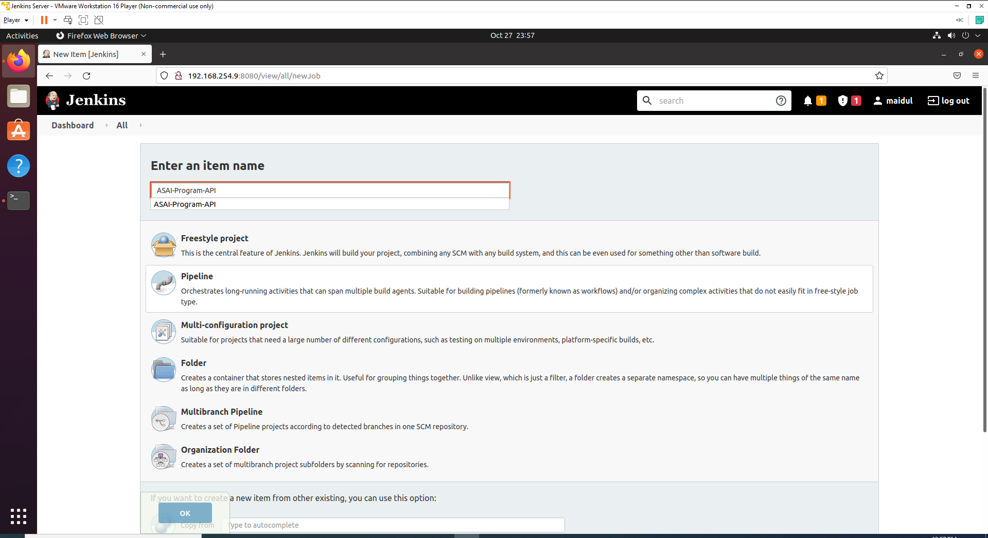

1. Go back to dashboard and you will see the list of pipeline.

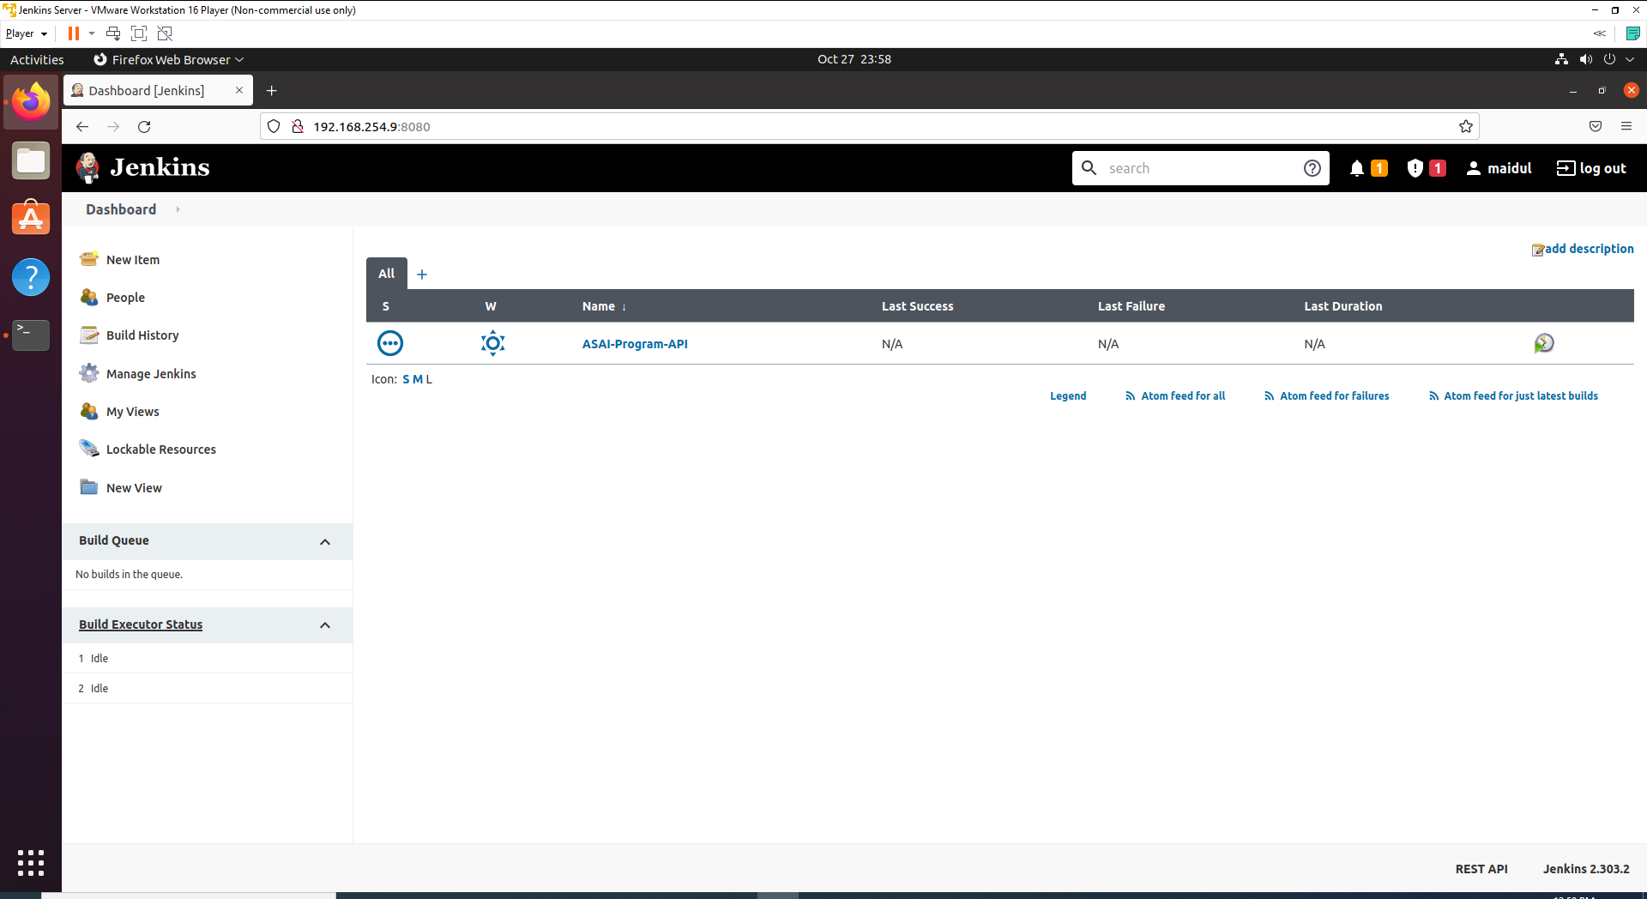

## Step 2: Store GIT Credentials

The rules of Jenkins password is not to store plain text password inside Jenkins script. Jenkins Manage Credential provides very elegant way to store GitHub Username and Password.

1. Goto : Jenkins -> Manage Jenkins -> Manage Credentials

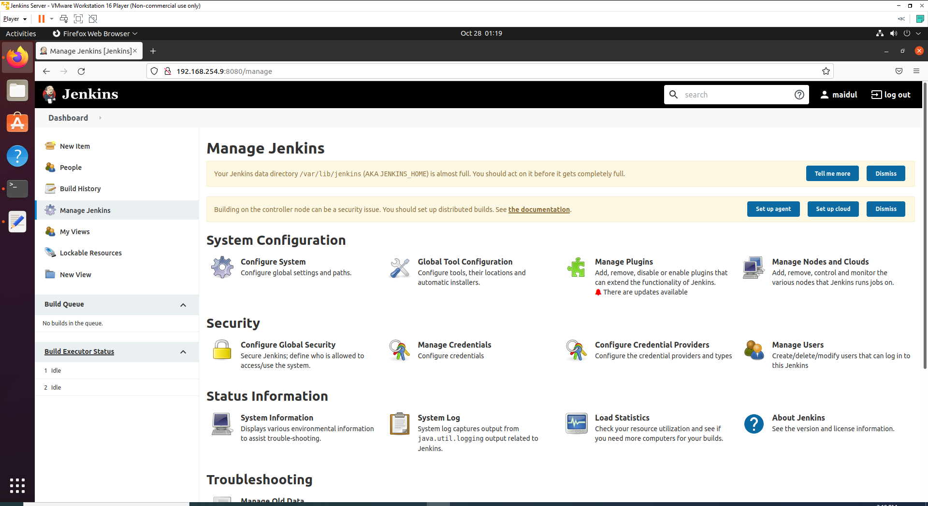

1. Go to Stores scoped to Jenkins -> global

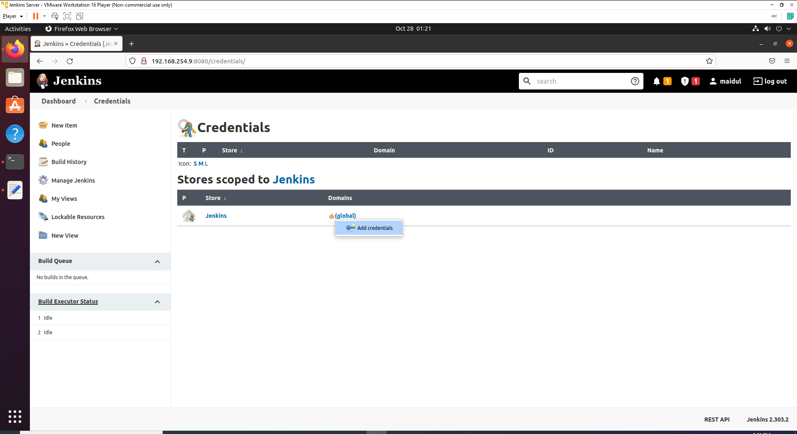

1. Select Username with Password and filled up with your GitHub credentials.

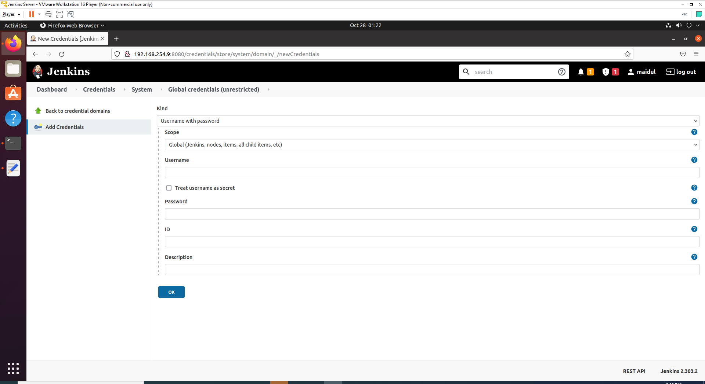

1. Click Ok.

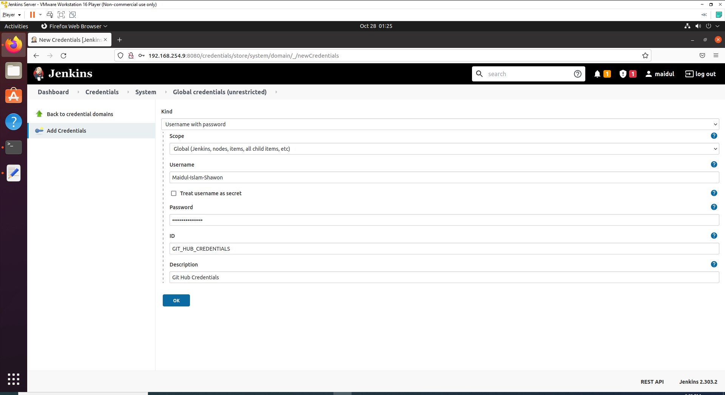

***Note - Keep the ID somewhere store so that you can remember ID- GIT_HUB_CREDENTIALS***

1. After complete above steps you will You will see your github credentials like below.

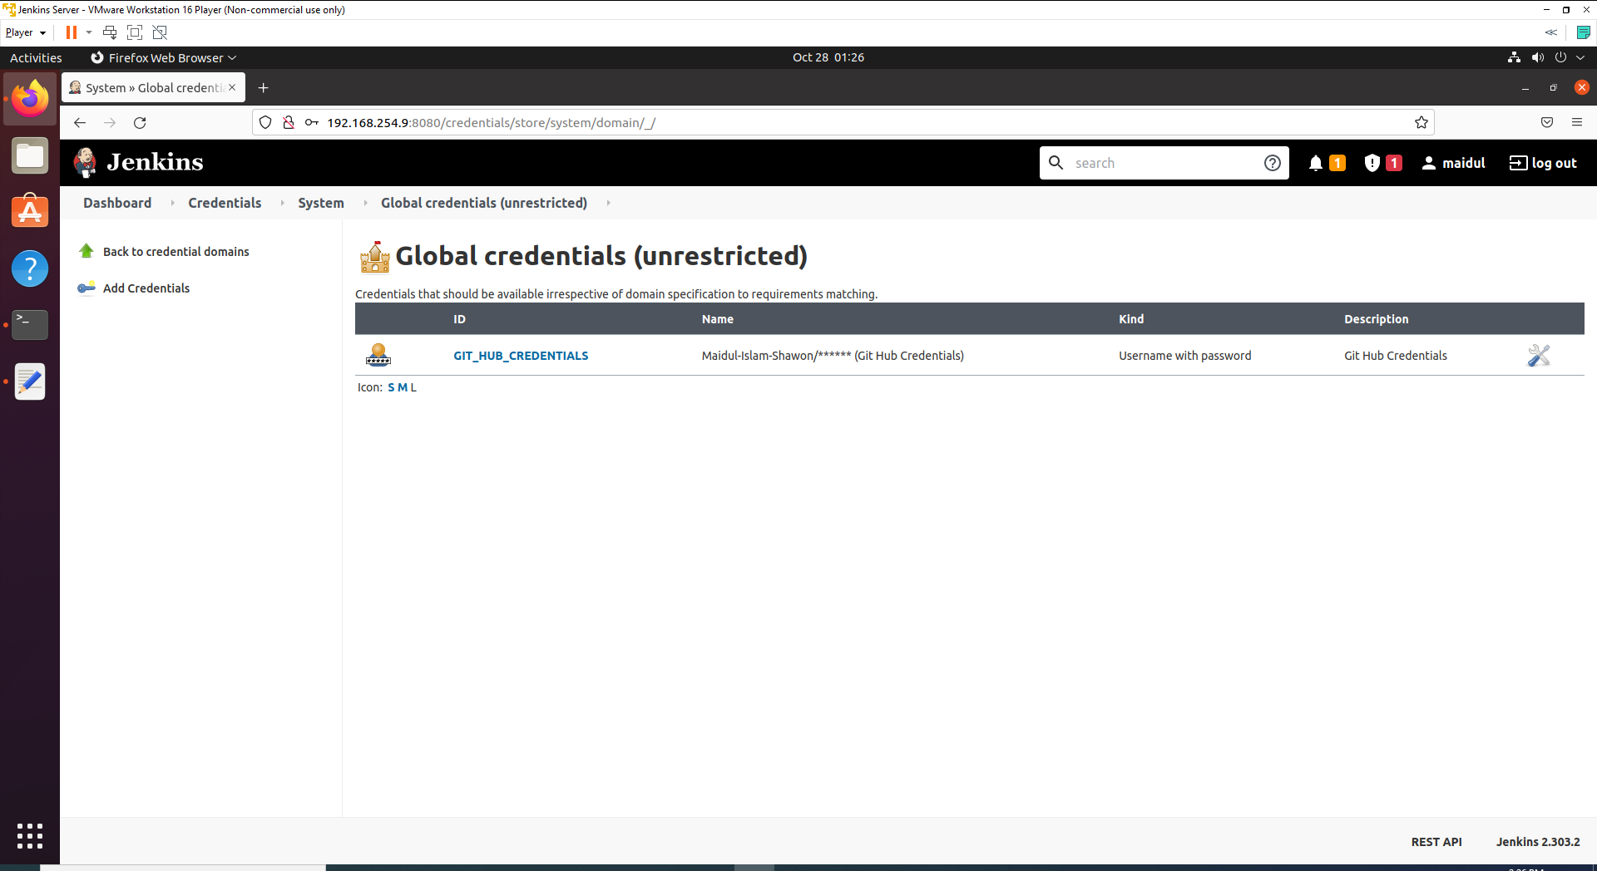

## Step 3: Clone the Git Repositories

First we are going to clone the source code form GIT repository and it is the first principal of the CI/CD pipeline.

1. Click on **ASAI-Program-API** from the list of pipeline and click on **Configure** from side nav.

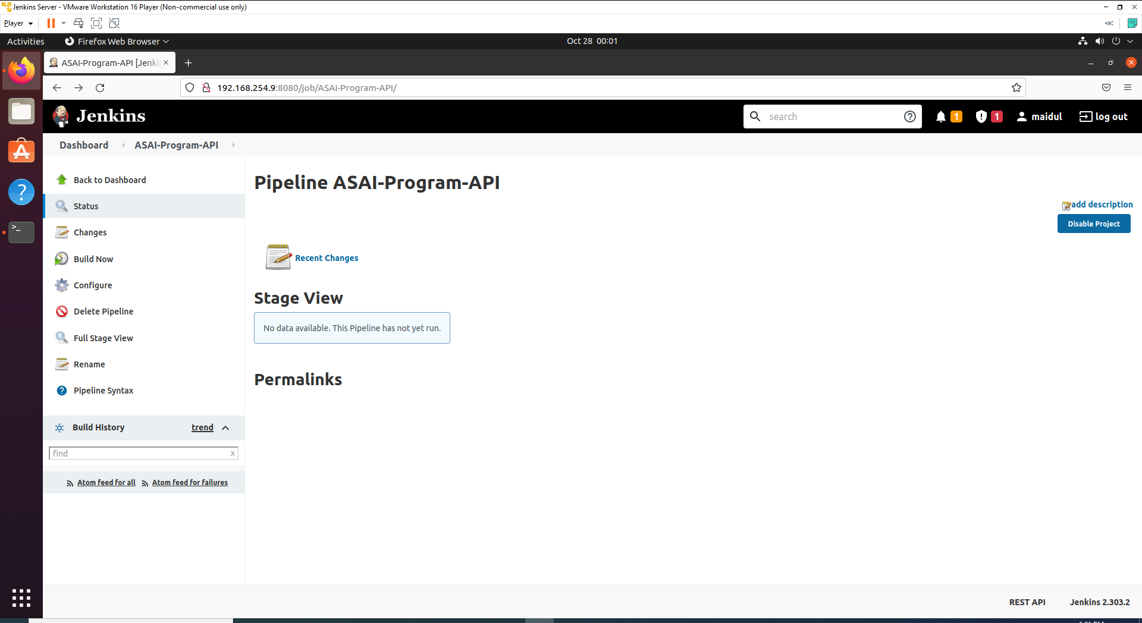

1. Go to **pipeline.**

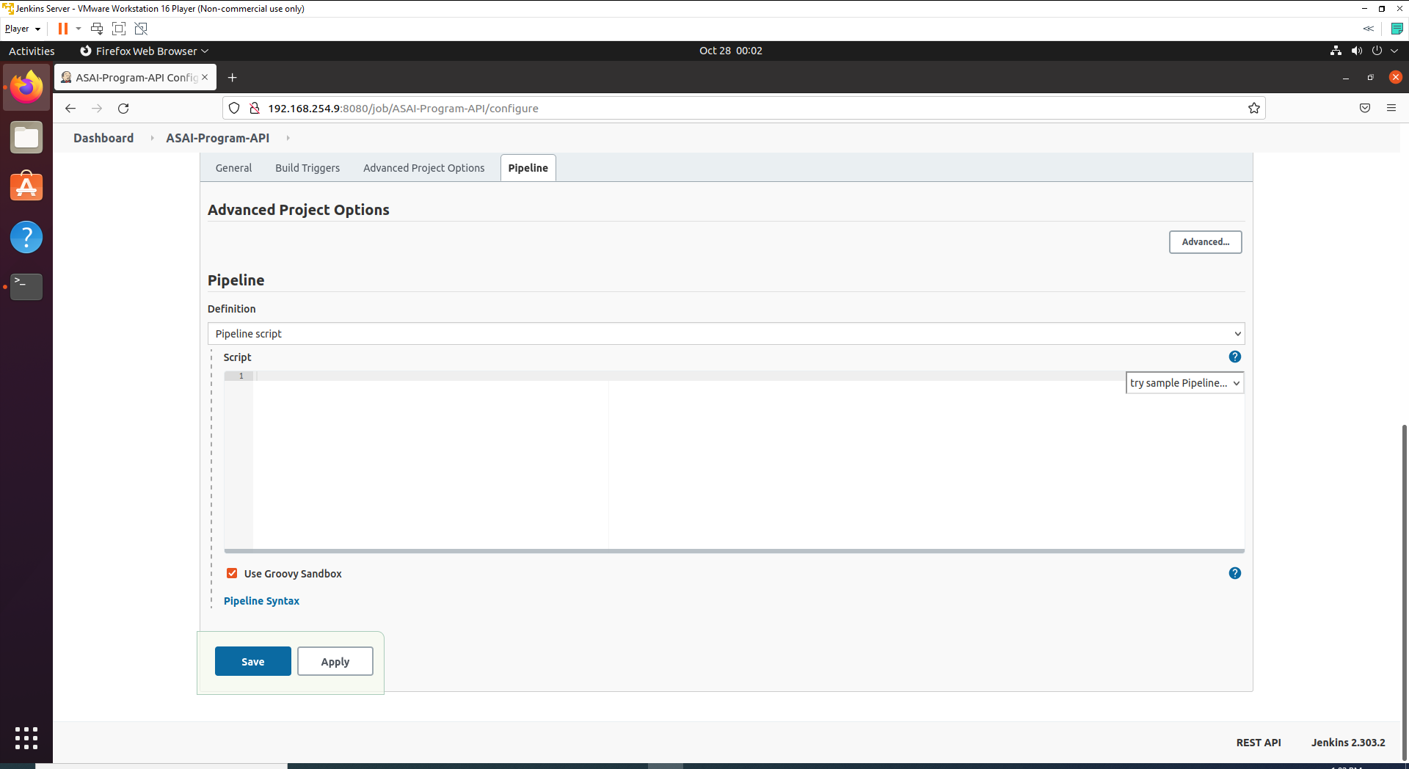

1. Now write below script to clone the repository on pipeline section.

node{

stage("Git Clone"){

git credentialsId: 'GIT_HUB_CREDENTIALS', url: 'https://github.com/Maidul-Islam-Shawon/ASAI-Program.git'

}

}

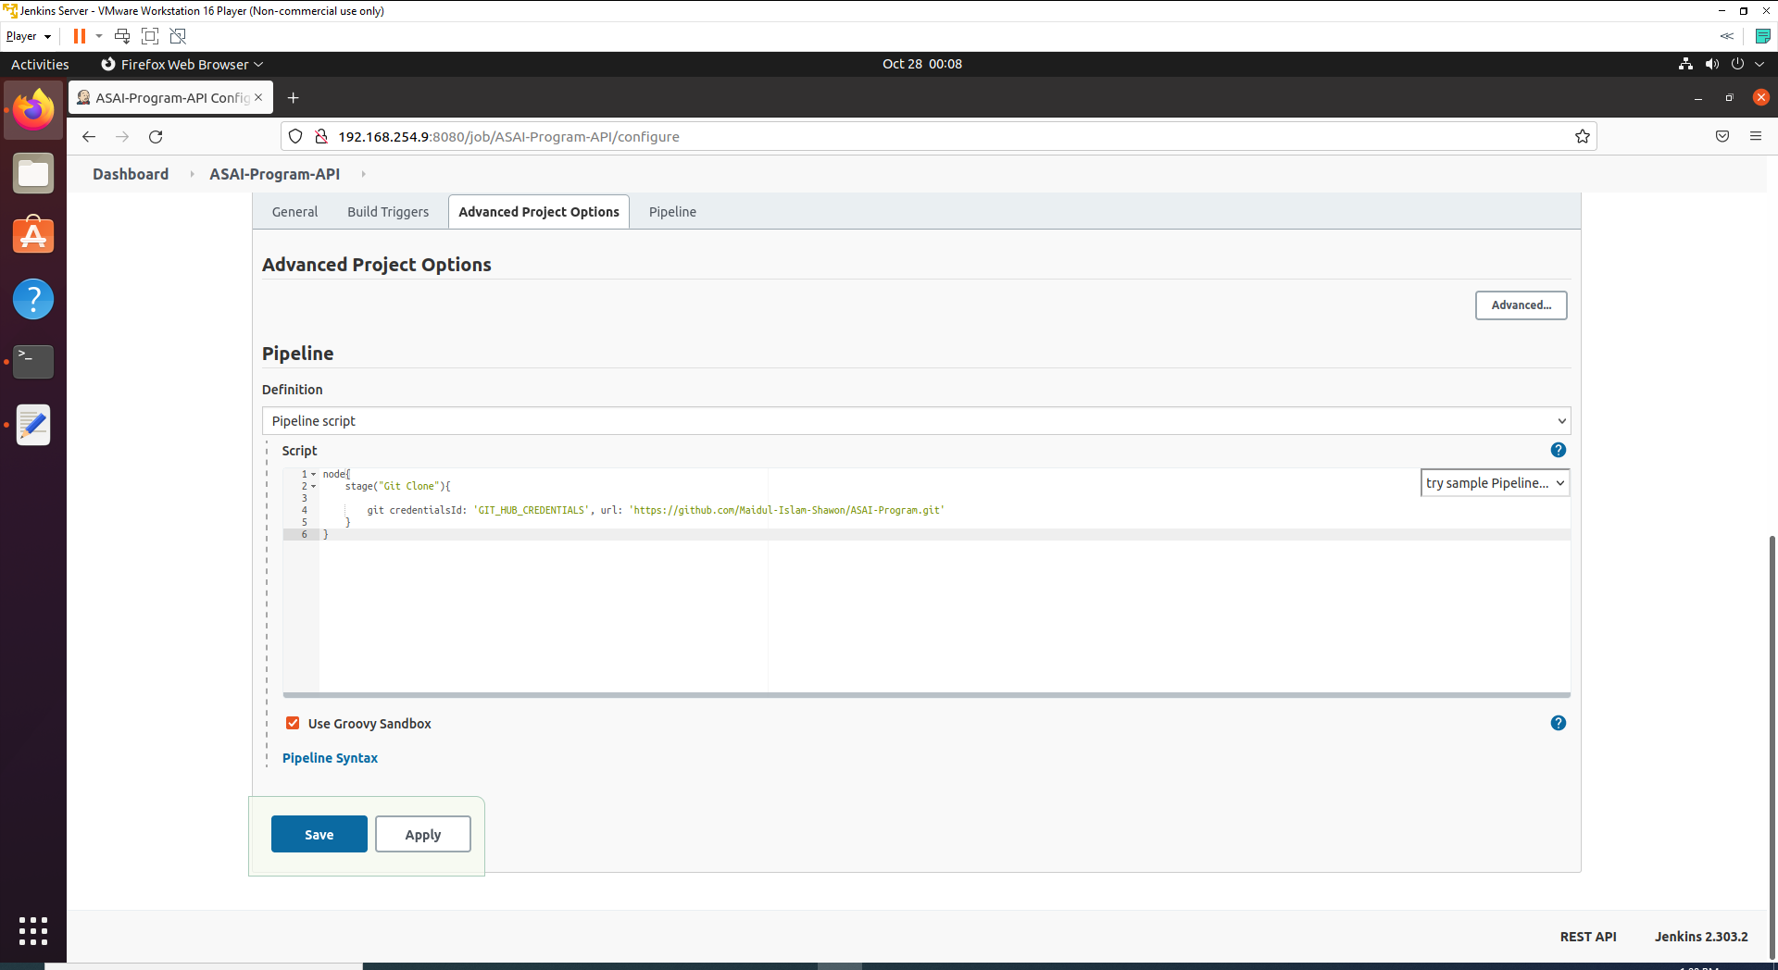

1. Click **Apply** and **Save**.
2. Go to Dashboard and click on ASAI-Program-API and click on Build Now from side nav.

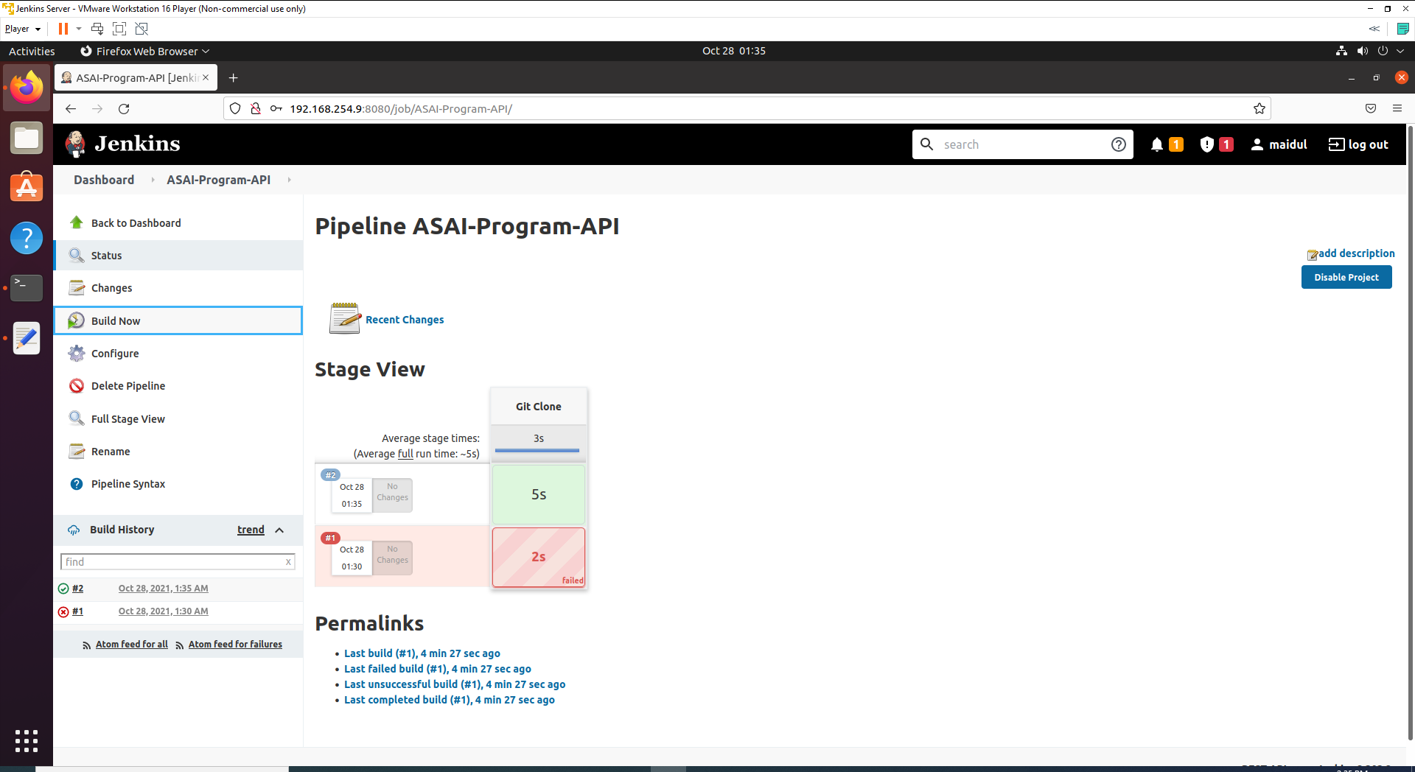

1. If build succeeded, a green box output will be visible. It can also verify from Console Output.

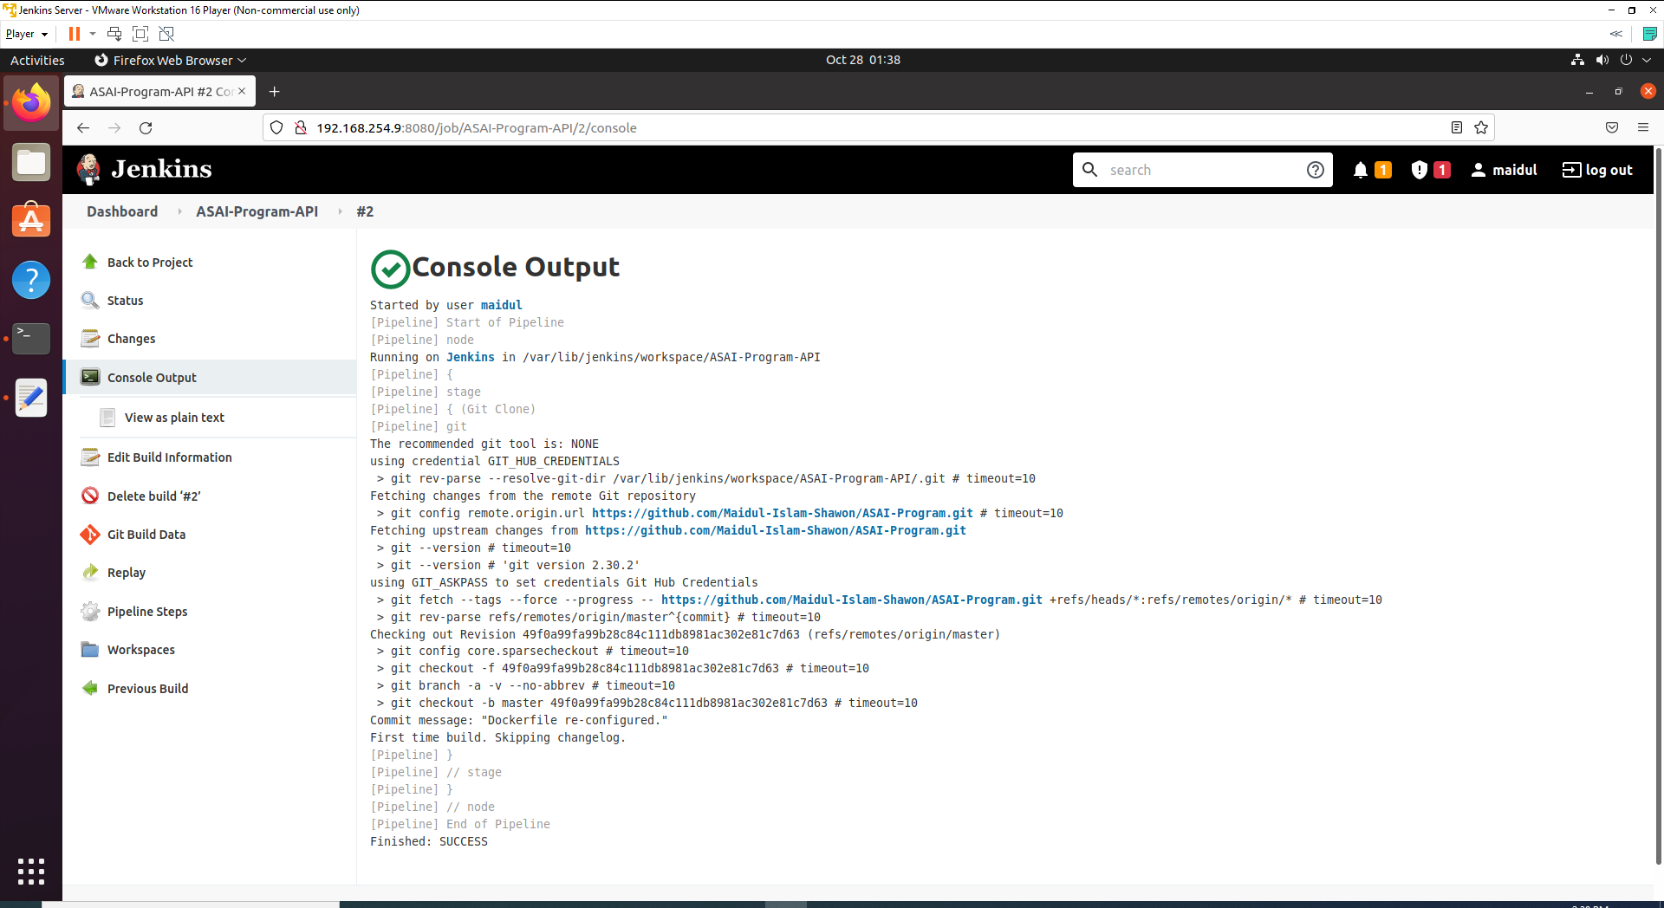

## Step 4: Script for Dotnet and build

1. Now go back to inside Genkins> ASAI-Program-API>Configure>Pipeline and add following script inside node section and after Git Clone stage.

node {

stage("Git Clone")

{

git credentialsId: 'GIT_HUB_CREDENTIALS', url: 'https://github.com/Maidul-Islam-Shawon/ASAI-Program.git', branch: 'master'

}

stage('Restore PACKAGES')

{

sh 'dotnet restore'

}

stage('Clean')

{

sh 'dotnet clean'

}

stage('Build')

{

sh 'dotnet build --configuration Release'

}

stage('Pack')

{

sh 'dotnet pack --no-build --output nupkgs'

}

}

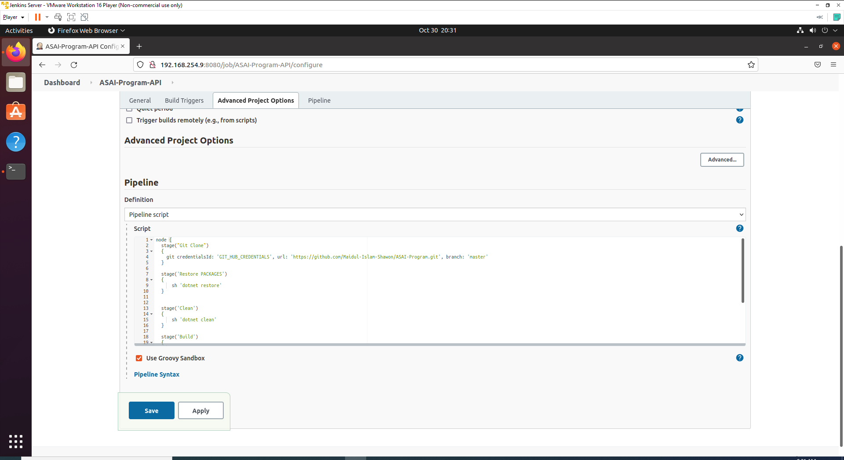

1. Apply and Save.
2. Now click on Build Now from side nav. You will see an output like below if no error occurs.

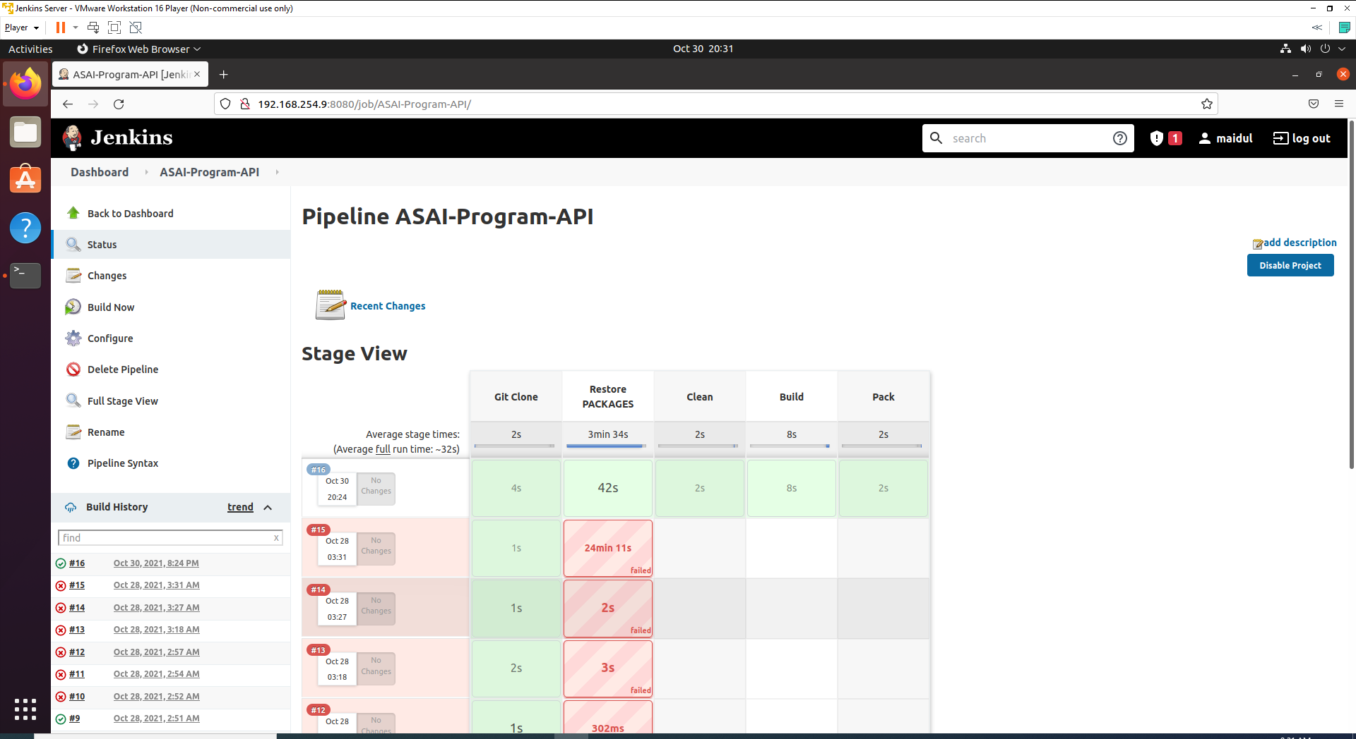

At the left bottom, you can check the build history.

## Step 5: Build Docker image and tag it

1. Now we are going to copy the Dockerfile to the root directory. Error will have occurred if we do not copy the Docker file to the root director. Open terminal console and write below command.

cd /var/lib/jenkins/workspace/ASAI-Program-API/Program

sudo cp Dockerfile /var/lib/jenkins/workspace/ASAI-Program-API/

1. Now we are going to build Docker Image and after that going to tag it with the name asai-program-api.
2. Now go to Genkins> ASAI-Program-API>Configure>Pipeline section and add following command at the below.

stage("Docker build"){

sh 'docker version'

sh 'docker build -t asai-program-api .'

sh 'docker image list'

sh 'docker tag asai-program-api maidulshawon/asai-program-api:1.0.0'

}

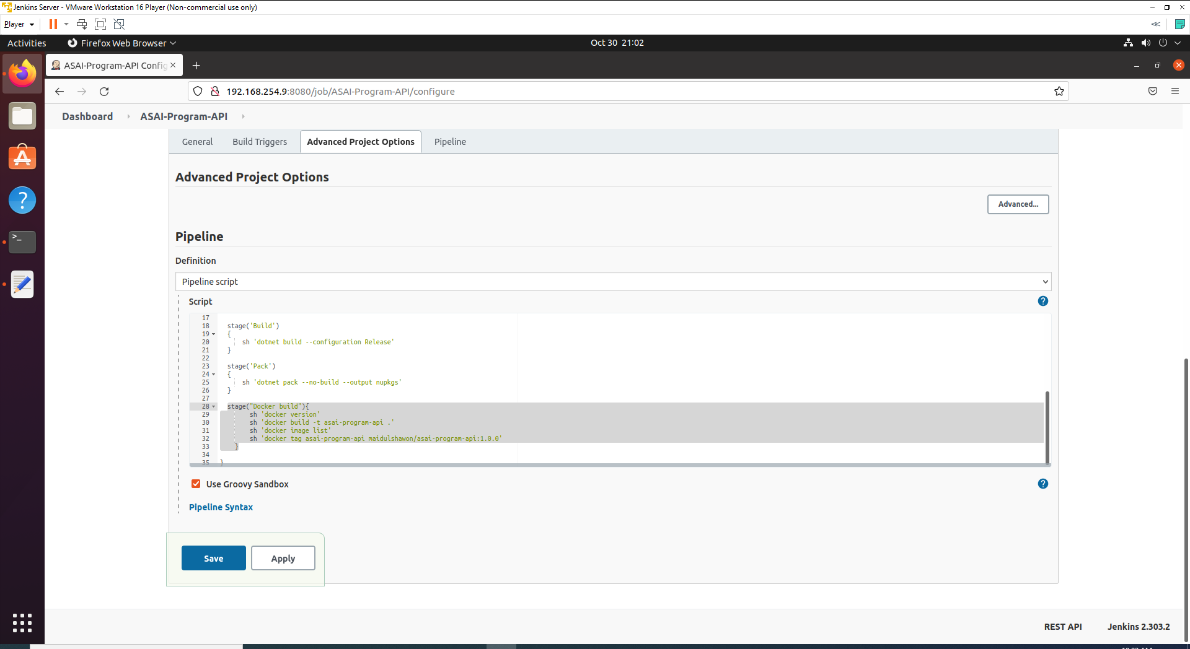

1. Apply and Save.
2. Now click on Build Now from side nav. You will see an output like below if no error occurs.

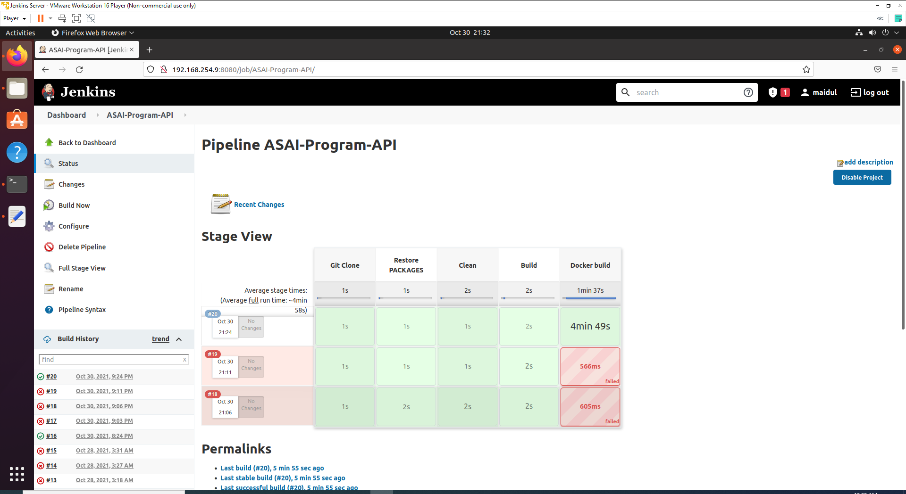

## Step 6: Store Docker Hub Credentials

Now we are going to store docker hub credentials inside Jenkins to use it on script.

1. Go to Jenkins -> Manage Jenkins -> Manage Credentials -> Stored scoped to jenkins -> global -> Add Credentials

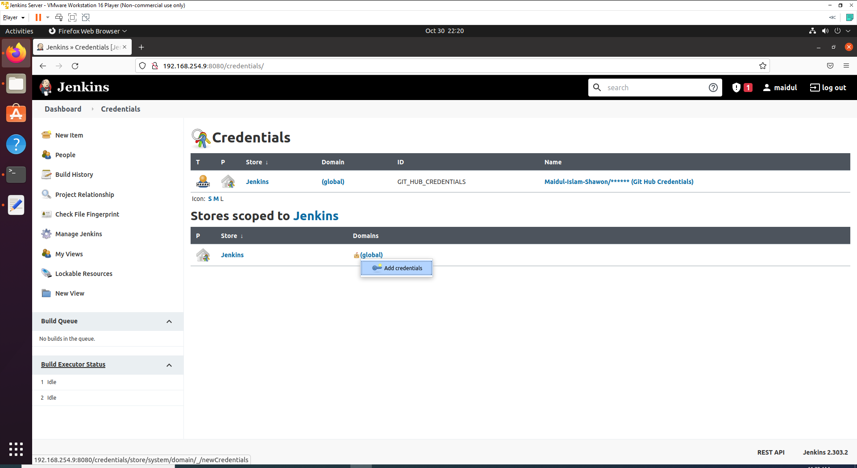

1. From the Kind dropdown please select **Secret text**

* Secret – In the Secret field, enter your docker hub password.
* ID – Enter any Id name such as DOCKER_HUB_PASSWORD
* Description – write any meaningful description such as Docker Hub password

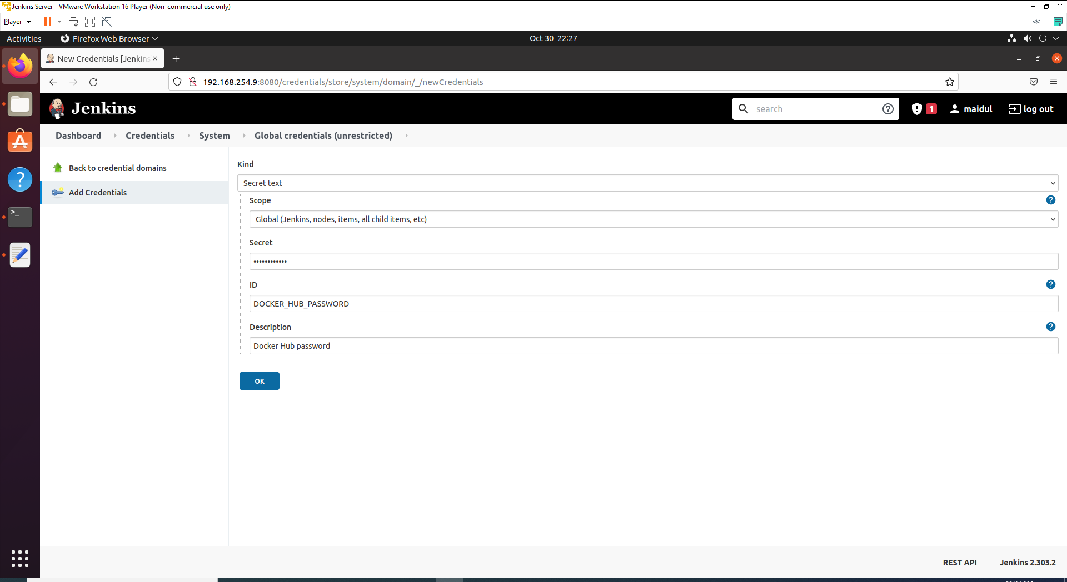

1. Click Ok after you enter Credentials.

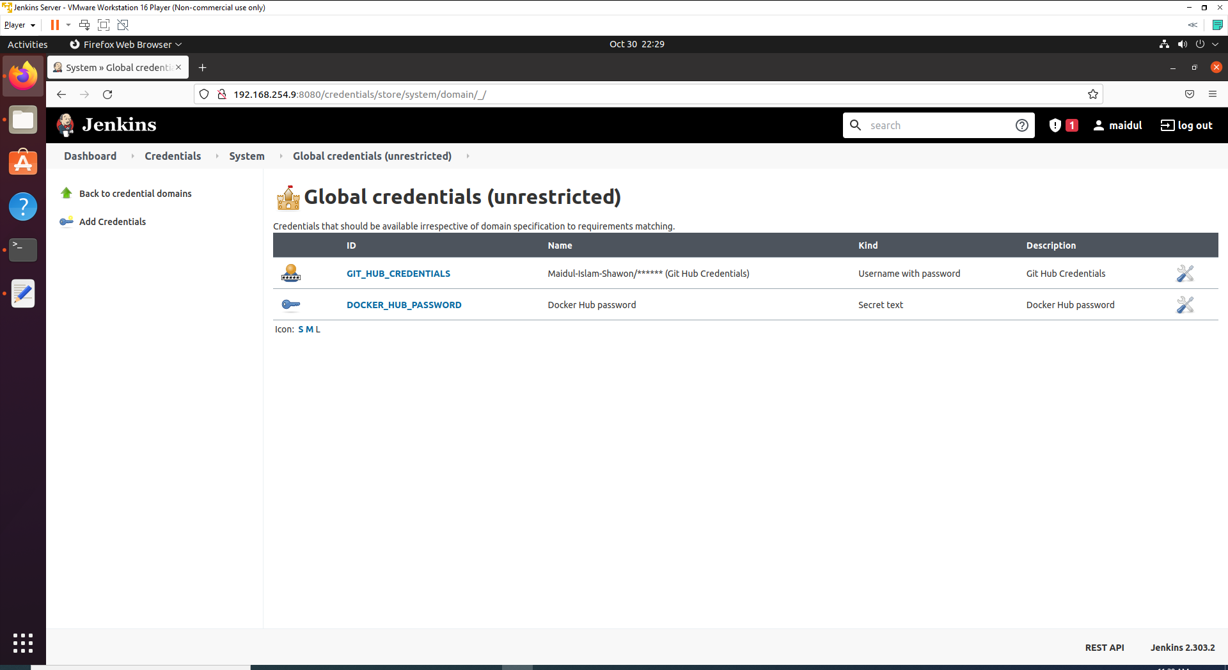

On the above list, you can see Git Hub Credentials and Docker Hub Password.

## Step 7: Docker Login via CLI

1. Now go to Genkins> ASAI-Program-API>Configure>Pipeline section and add following script at the bottom.

stage("Docker Login"){

withCredentials([string(credentialsId: 'DOCKER_HUB_PASSWORD', variable: 'PASSWORD')]) {

sh 'docker login -u **USERNAME** -p $PASSWORD'

}

}

1. After building and tagging the Docker Image we need to push it to the DockerHub. But before we push to DockerHub we need to authenticate via CLI(command line interface) using docker login.

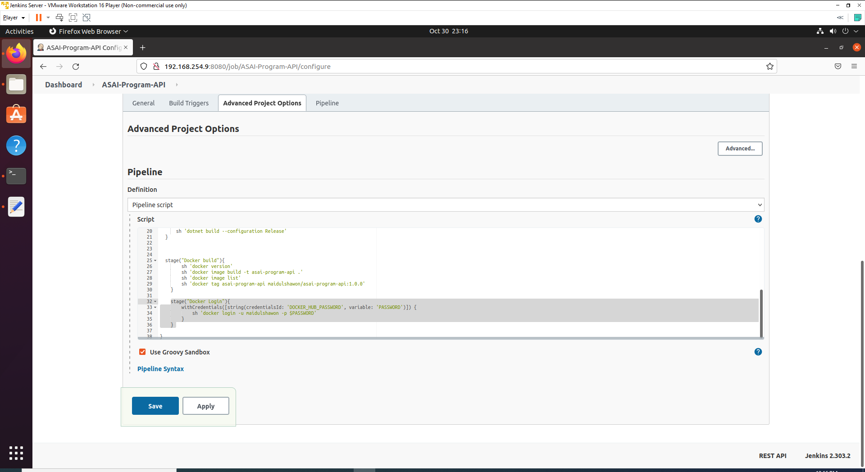

1. Apply and Save.
2. Now click on Build Now from side nav to build the pipeline. You will see an output like below if no error occurs.

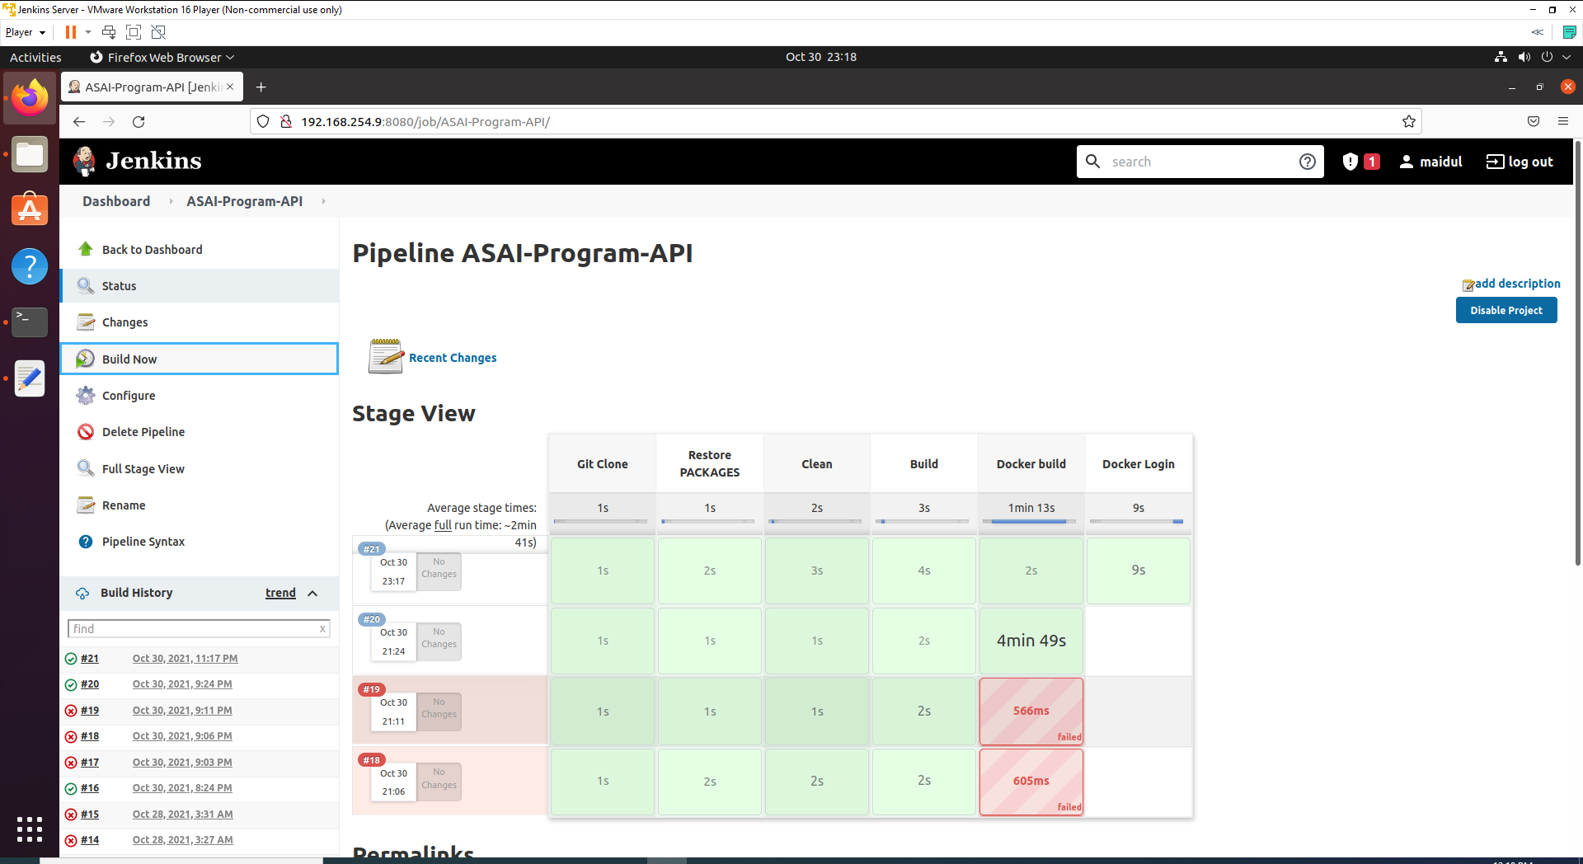

## Step 8: Push Docker Image into DockerHub

We need to push the image to docker hub after we build the image and login.

1. Use below command to find docker image name in the system with below command. Please write below command on the console and you will see list of docker images in the system.

docker image ls

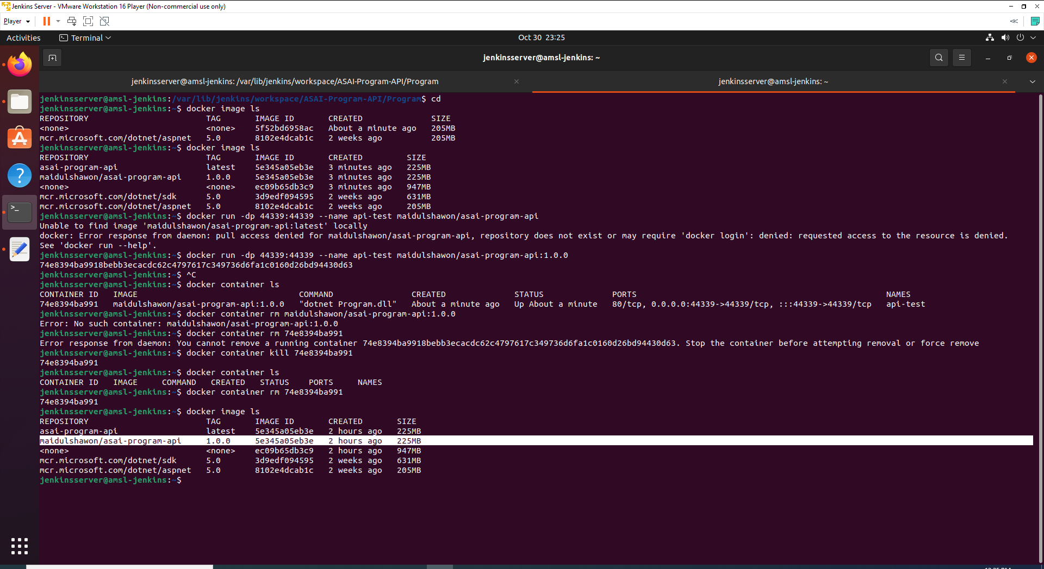

1. Now go back to Genkins> ASAI-Program-API>Configure>Pipeline section and add following command at the bottom.

stage("Push Image to Docker Hub"){

sh 'docker push maidulshawon/asai-program-api:1.0.0'

}

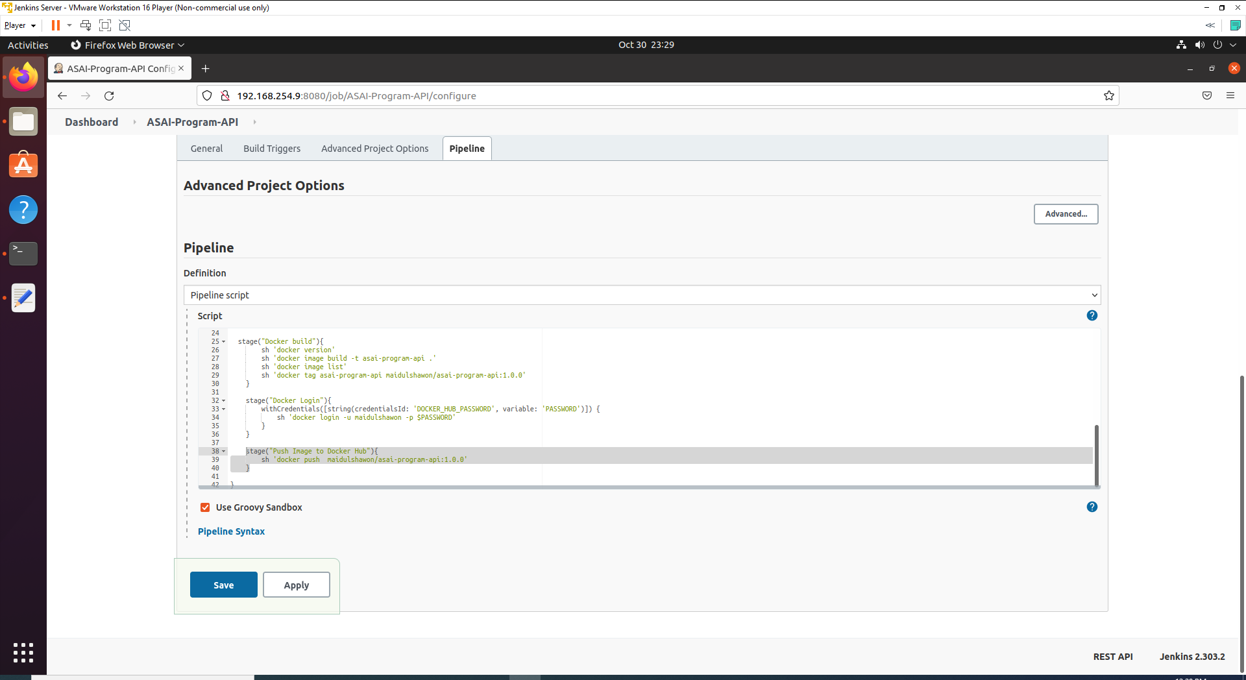

1. Apply and Save.
2. Now click on Build Now from side nav. You will see an output like below if no error occurs.

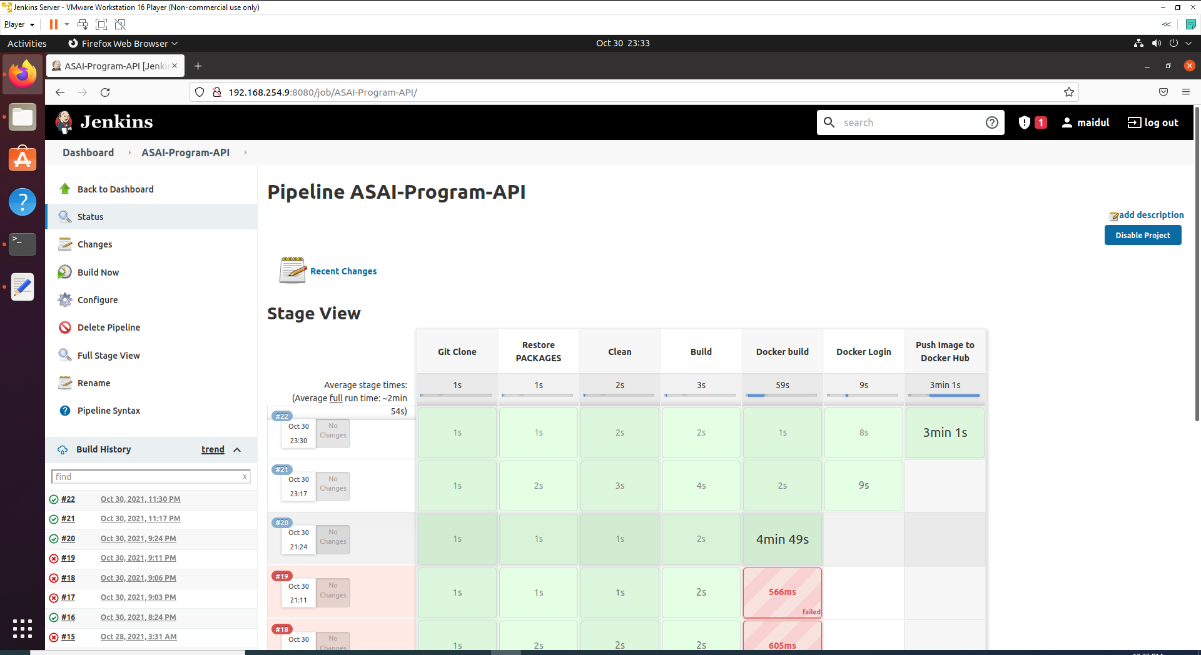

You can also check the console output.

1. Please also check on docker hub. If you image pushed successfully, you will see a output like below on the repository list.

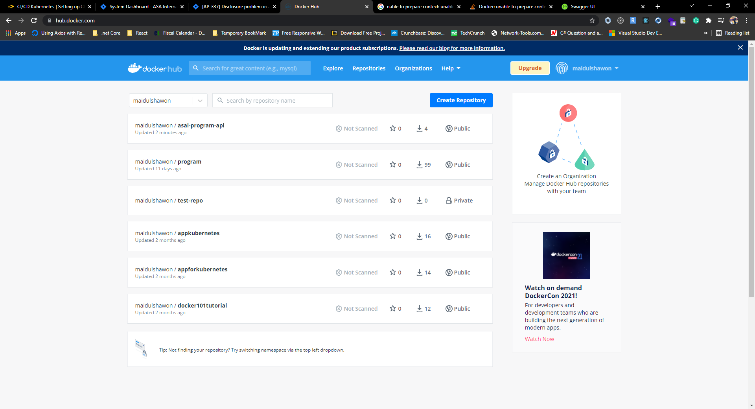

## Step 9: SSH into AMSL-Master Node

As we have installed SSH Pipeline Steps in step no - 5, now we are going to use that plugin to SSH into amsl-master server.

1. Now go back to Genkins> ASAI-Program-API>Configure>Pipeline section and add following command at the bottom.

stage("SSH Into AMSL-Master node") {

def remote = [:]

remote.name = 'amsl-master'

remote.host = '192.168.254.10'

remote.user = 'master'

remote.password = 'ENTER_YOUR_PASSWORD'

remote.allowAnyHosts = true

}

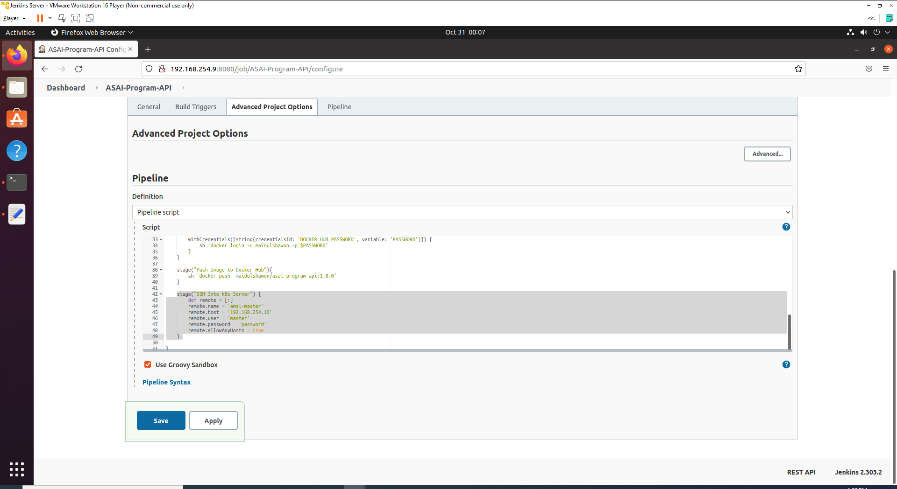

1. Apply and Save.
2. Now click on Build Now from side nav. You will see an output like below if no error occurs.

## Step 10: Deployment and Service

Now we are going to create a deployment and service file inside our API.

1. Create a file in the root directory of your Dotnet application and name the file program-deployment-service.yaml.
2. Write below code inside the YAML file.

apiVersion: apps/v1

kind: Deployment

metadata:

labels:

app: amsl-program-api

name: amsl-program-api

spec:

replicas: 3

selector:

matchLabels:

app: amsl-program-api

strategy: {}

template:

metadata:

creationTimestamp: null

labels:

app: amsl-program-api

spec:

affinity:

nodeAffinity:

requiredDuringSchedulingIgnoredDuringExecution:

nodeSelectorTerms:

- matchExpressions:

- key: env

operator: In

values:

- prod

- dev

containers:

- image: docker.io/maidulshawon/asai-program-api:1.0.0

name: program-api-container

ports:

- containerPort: 44339

resources: {}

status: {}

---

apiVersion: v1

kind: Service

metadata:

labels:

app: amsl-program-api

name: amsl-program-api

spec:

type: LoadBalancer

externalIPs:

- 192.168.0.15

ports:

- port: 80

protocol: TCP

targetPort: 44339

selector:

app: amsl-program-api

status:

loadBalancer: {}

1. Now add and push the YAML file to GitHub repository with your dotnet project .

## Step 11: Copy program-deployment-service.yaml to AMSL-Master server

After successful login, copy program-deployment-service.yaml to AMSL-Master server.

1. Now go back to Genkins> ASAI-Program-API>Configure>Pipeline section and add following command at the bottom. **(Insert following stage as sub-stage of “SSH Into AMSL-Master node” stage.**

stage('Copy program-deployment-service.yaml onto amsl-master') {

sshPut remote: remote, from: 'program-deployment-service.yaml', into: '.'

}

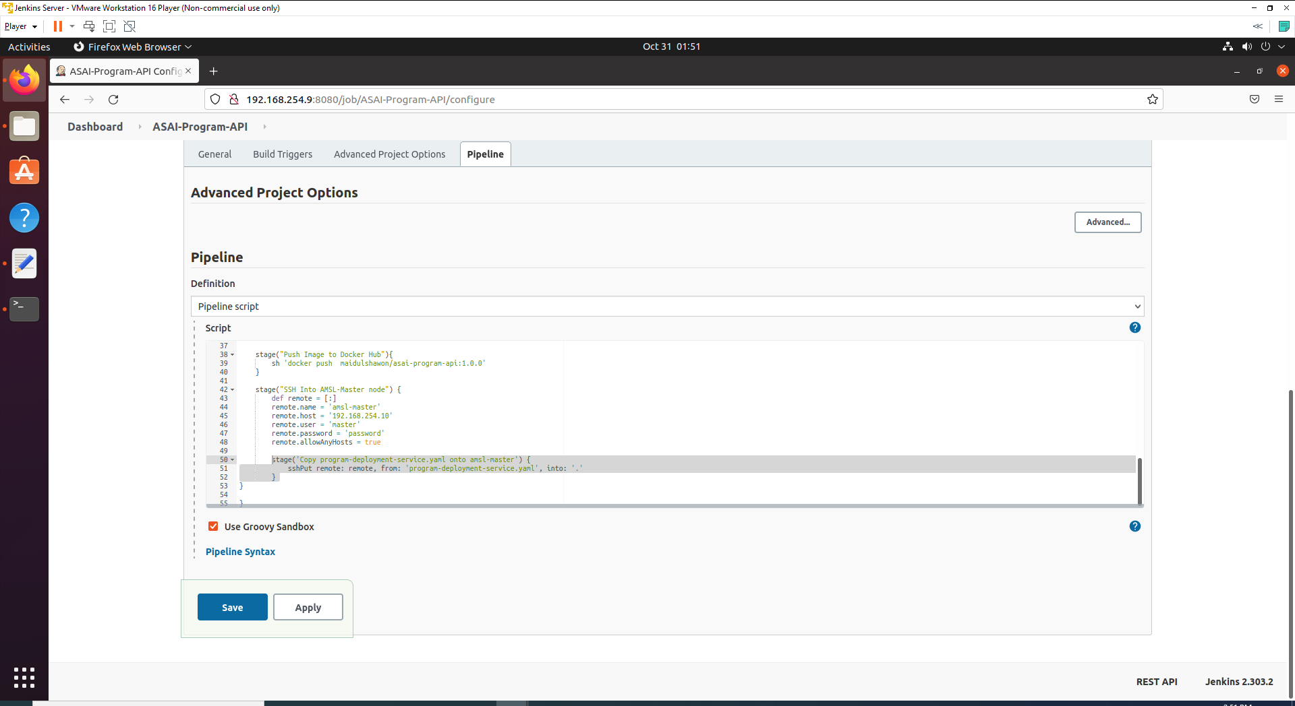

Now Jenkins going to perform a copy to the current working directory of Master Node.

1. Apply and Save.
2. Now click on Build Now from side nav. You will see an output like below if no error occurs.

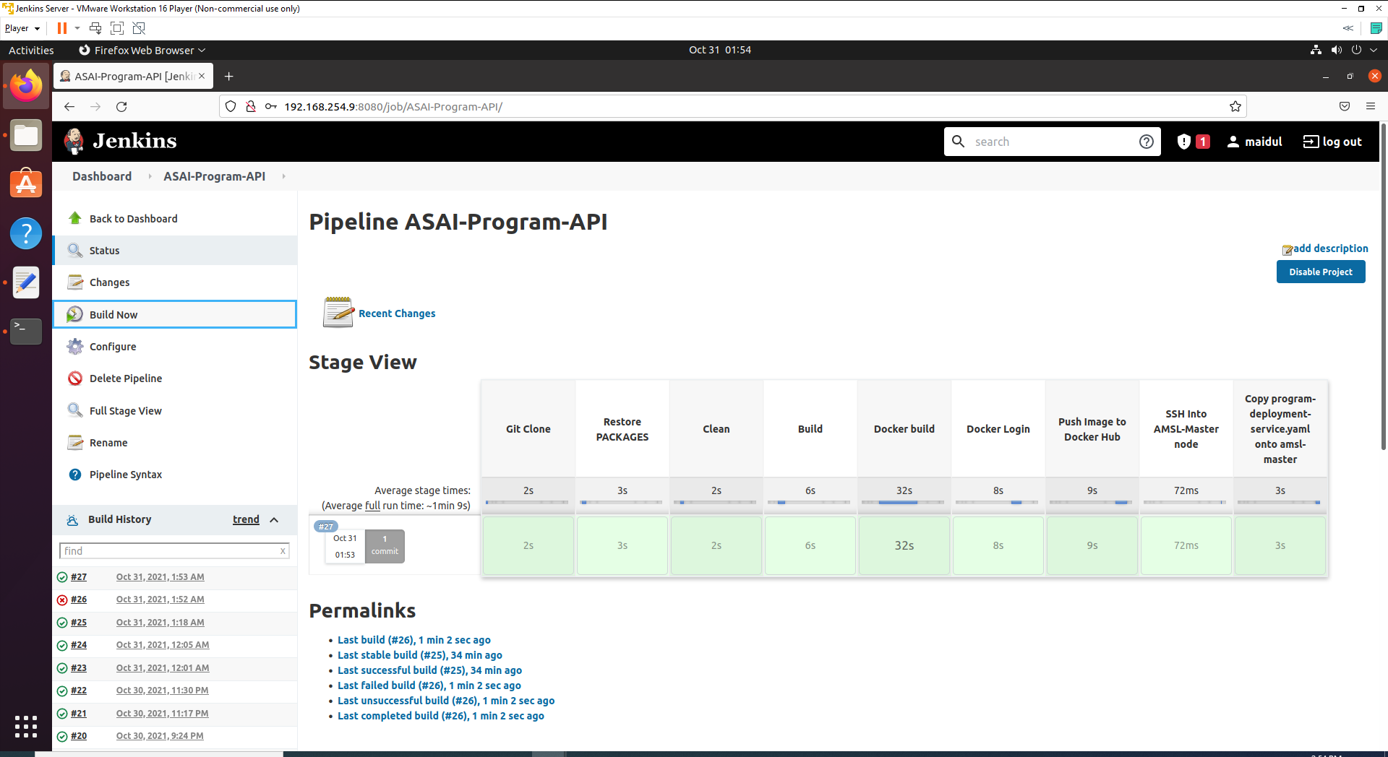

1. Now we are going to check the copied YAML file inside master node.
2. Login to AMSL-Mster Node and open console terminal and write below command.

ls

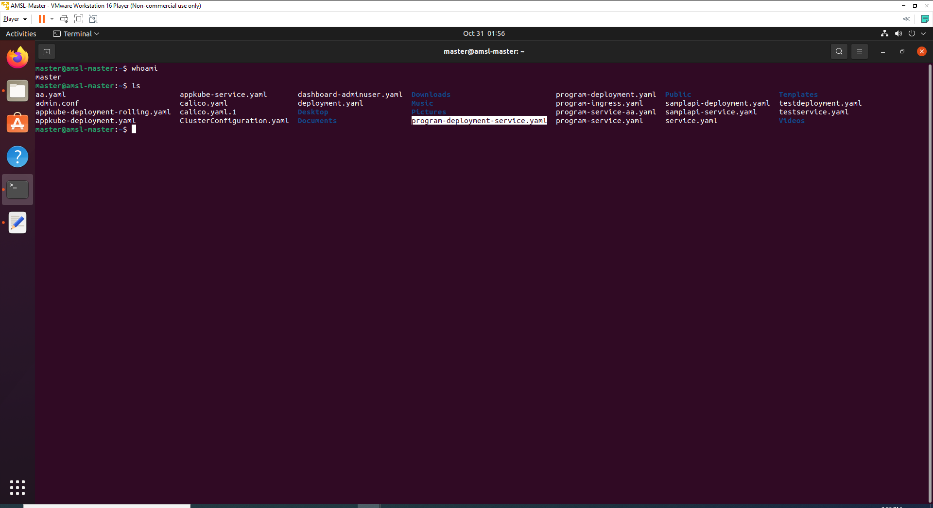

Here we can see that the YAML file copies successfully.

## Step 12: Create kubernetes deployment and service

After coping file, we have to perform another sub-stage to execute or apply the deployment and service within the cluster.

1. Now go back to Genkins> ASAI-Program-API>Configure>Pipeline section and add following command at the bottom. **(Insert following stage as sub-stage of “SSH Into AMSL-Master node” stage.**

stage('Deploy Dotnet API') {

sshCommand remote: remote, command: "kubectl apply -f program-deployment-service.yaml"

}

1. Above command will apply the **program-deployment-service.yaml** which will Create a deployment with name - amsl-program-api and expose a service as LoadBalancer and external IP - **192.168.0.15**.

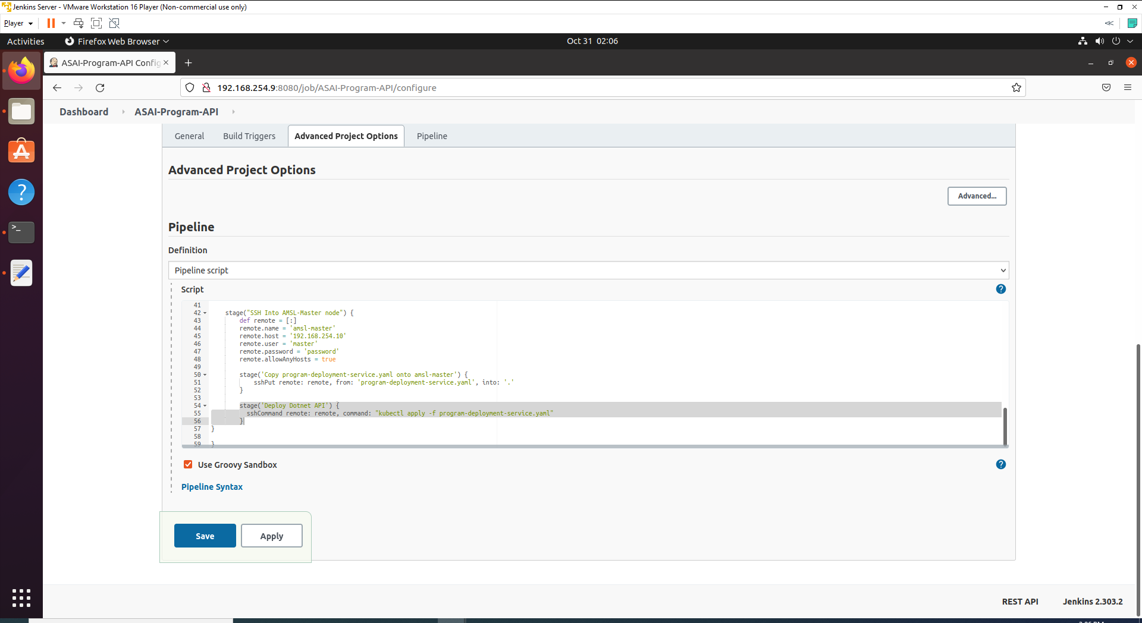

3. Apply and Save.  
4. Now click on Build Now from side nav. You will see an output like below if no error occurs.

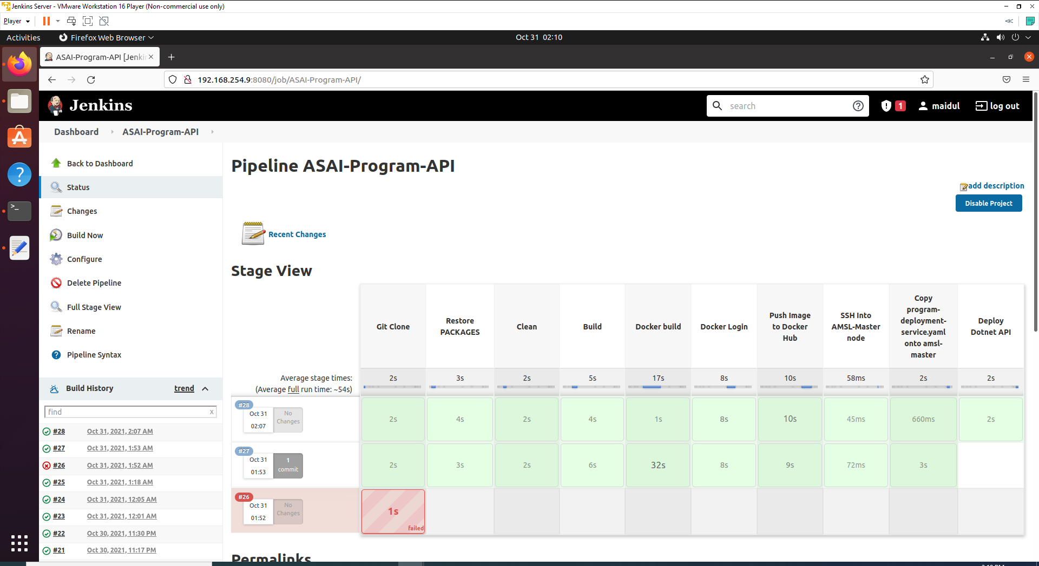

## Step 13: Complete Script for CI/CD pipelines Jenkins

So here is the final complete pipeline script for my CI/CD Jenkins kubernetes pipeline.

node {

stage("Git Clone")

{

git credentialsId: 'GIT_HUB_CREDENTIALS', url: 'https://github.com/Maidul-Islam-Shawon/ASAI-Program.git', branch: 'master'

}

stage('Restore PACKAGES')

{

sh 'dotnet restore'

}

stage('Clean')

{

sh 'dotnet clean'

}

stage('Build')

{

sh 'dotnet build --configuration Release'

}

stage("Docker build"){

sh 'docker version'

sh 'docker image build -t asai-program-api .'

sh 'docker image list'

sh 'docker tag asai-program-api maidulshawon/asai-program-api:1.0.0'

}

stage("Docker Login"){

withCredentials([string(credentialsId: 'DOCKER_HUB_PASSWORD', variable: 'PASSWORD')]) {

sh 'docker login -u maidulshawon -p $PASSWORD'

}

}

stage("Push Image to Docker Hub"){

sh 'docker push maidulshawon/asai-program-api:1.0.0'

}

stage("SSH Into AMSL-Master node") {

def remote = [:]

remote.name = 'amsl-master'

remote.host = '192.168.254.10'

remote.user = 'master'

remote.password = 'password'

remote.allowAnyHosts = true

stage('Copy program-deployment-service.yaml onto amsl-master') {

sshPut remote: remote, from: 'program-deployment-service.yaml', into: '.'

}

stage('Deploy Dotnet API') {

sshCommand remote: remote, command: "kubectl apply -f program-deployment-service.yaml"

}

}

}

# Verify Deployment

Now we are going to verify the deployment.

1. Login to AMSL-Master Node.
2. Write below command to check deployment, replica sets and deployed pod.

kubectl get deployment

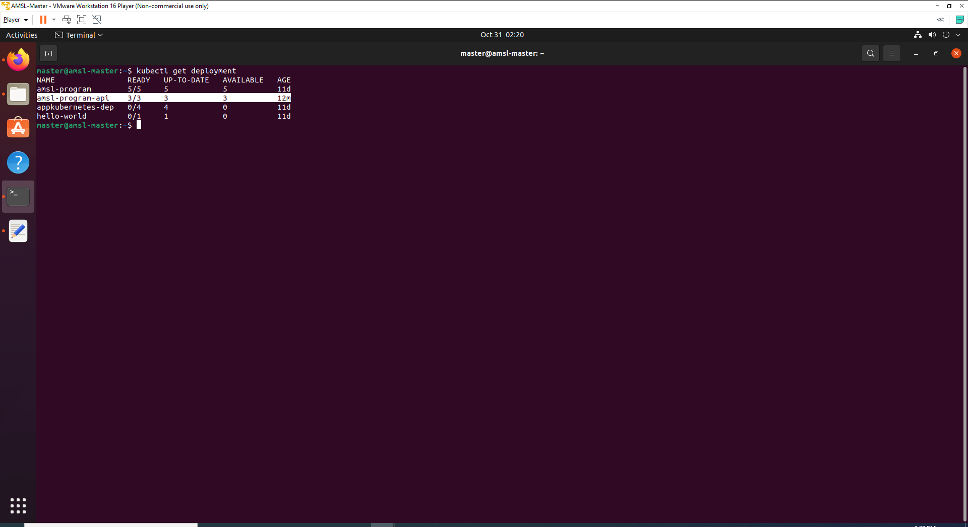

kubectl get pods -o wide

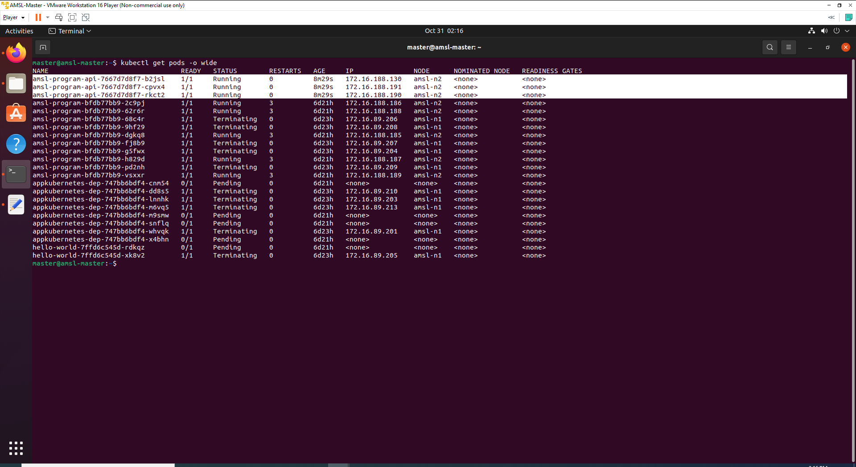

kubectl get replicaset -o wide

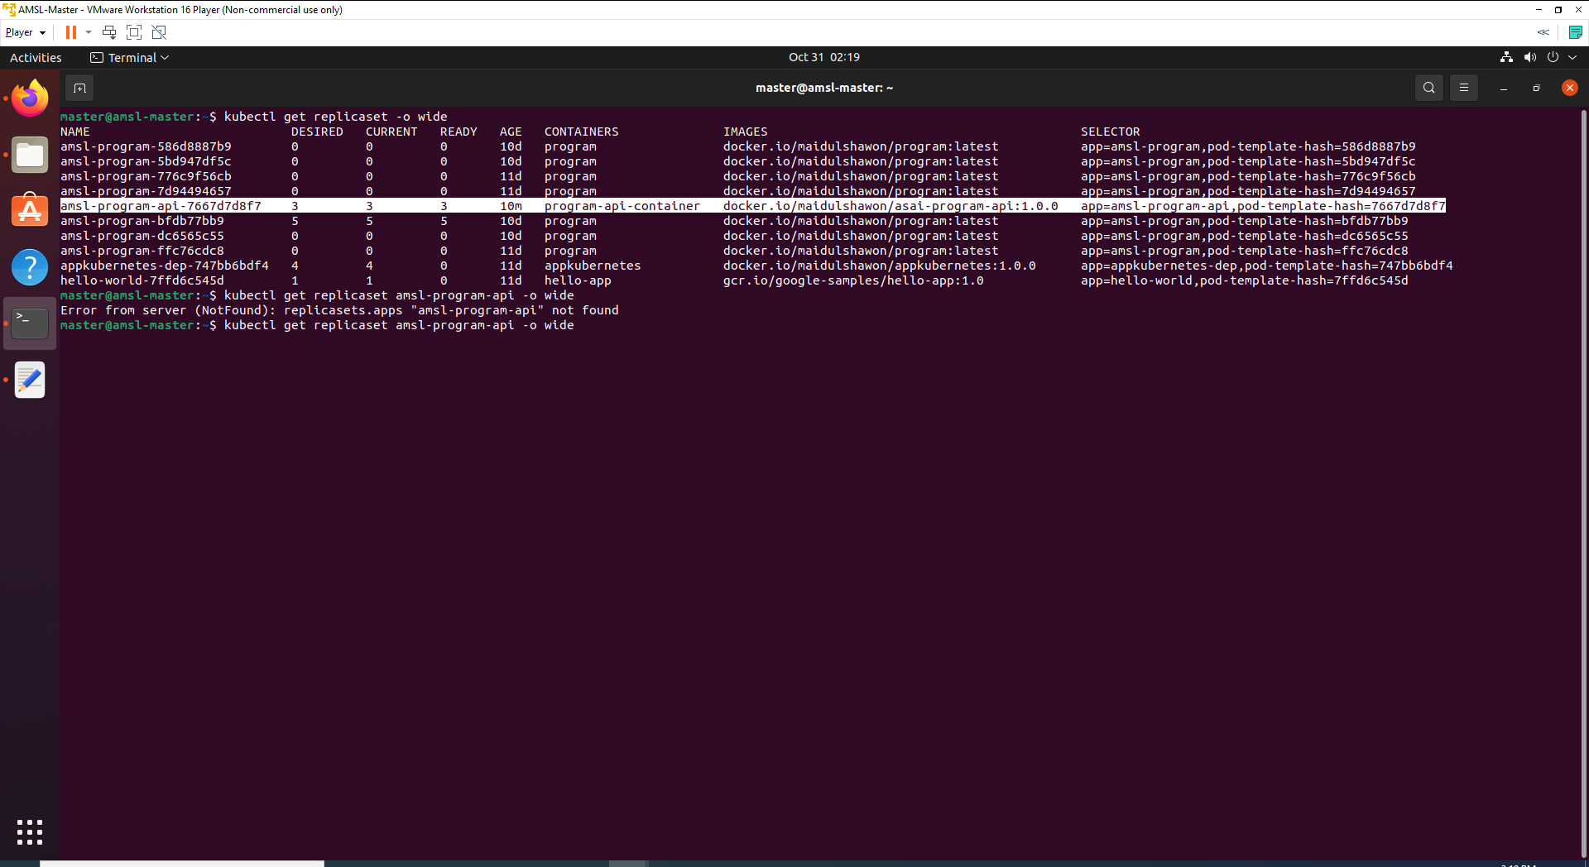

We can see from above output that deployment is up to date, all pods are running and deployed to node-2 *(Note: I have only running Node 2 as worker node due to memory issue.)*

1. Let’s check service with below command.

kubectl get services -o wide

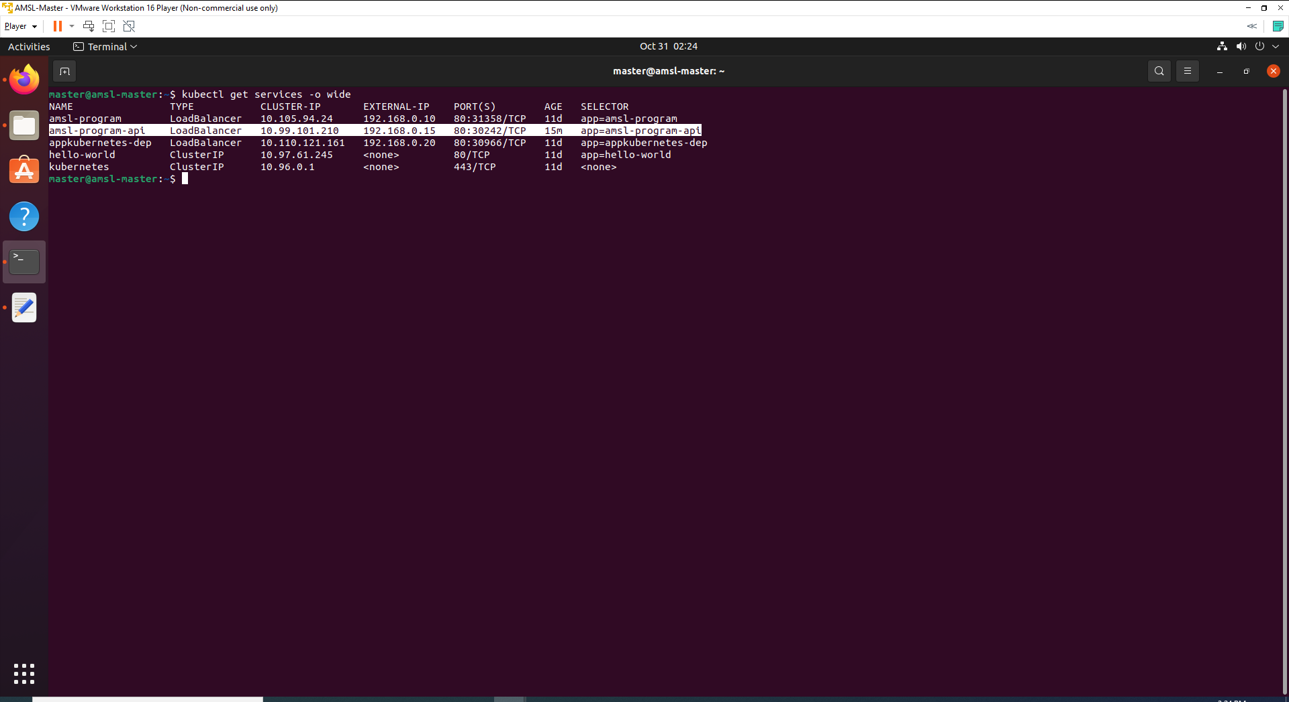

1. Open the web browser and check with External IP with valid endpoint. The correct endpoint for this application will be **http://192.168.0.15/swagger/index.html**

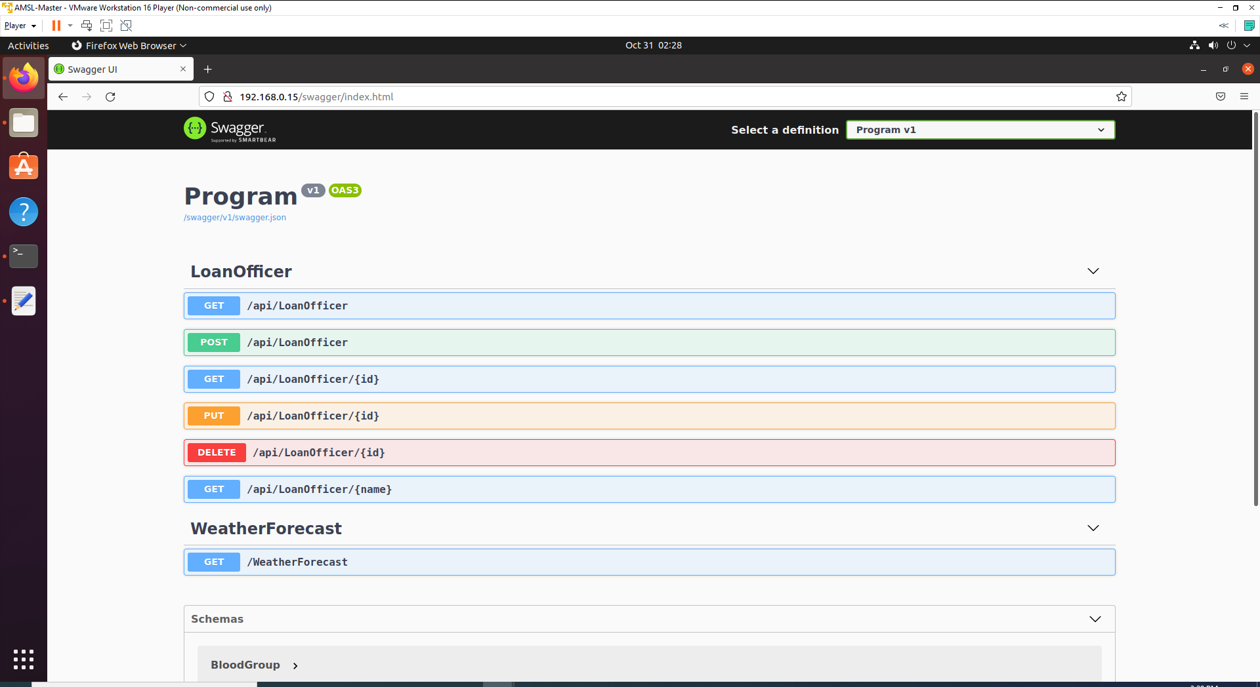

# Activate Automatic Jenkins Build

Our initial plan was to activate automatic build, so when any git push will occur, Jenkins will detect the Git push and start build all processes.

1. Now go back to Genkins> ASAI-Program-API>Configure>Build Triggers section.
2. Check on Poll SCM.
3. Write below text inside Schedule box.

*/1 * * * *

1. Apply and Save.

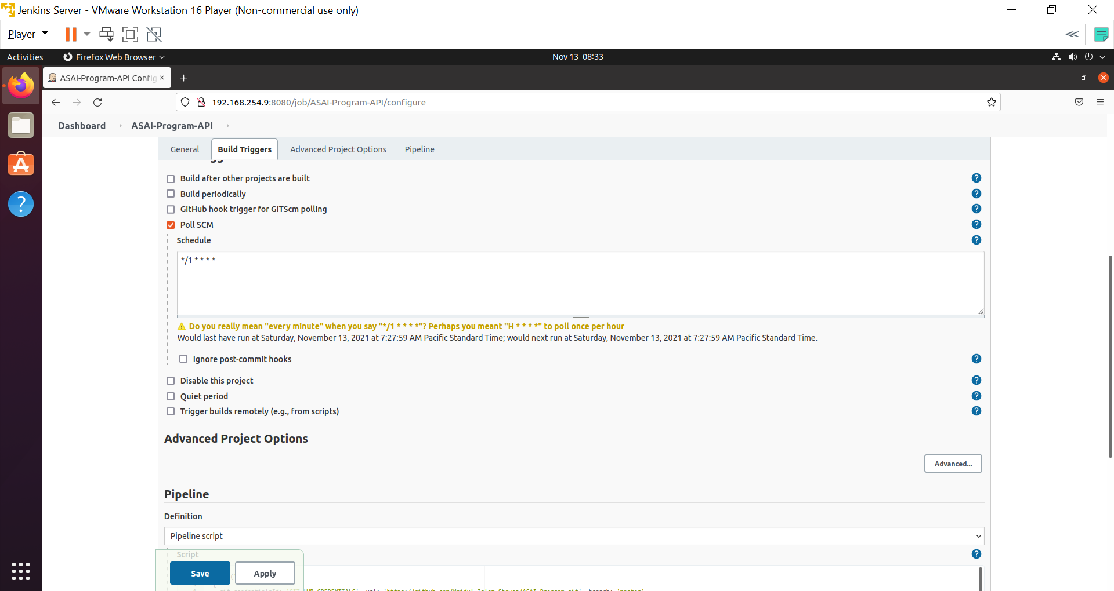

Now build will start automatically whenever any Git push will be done.

# Add Unit Test

I have added some unit test cases in my application using xUnit.

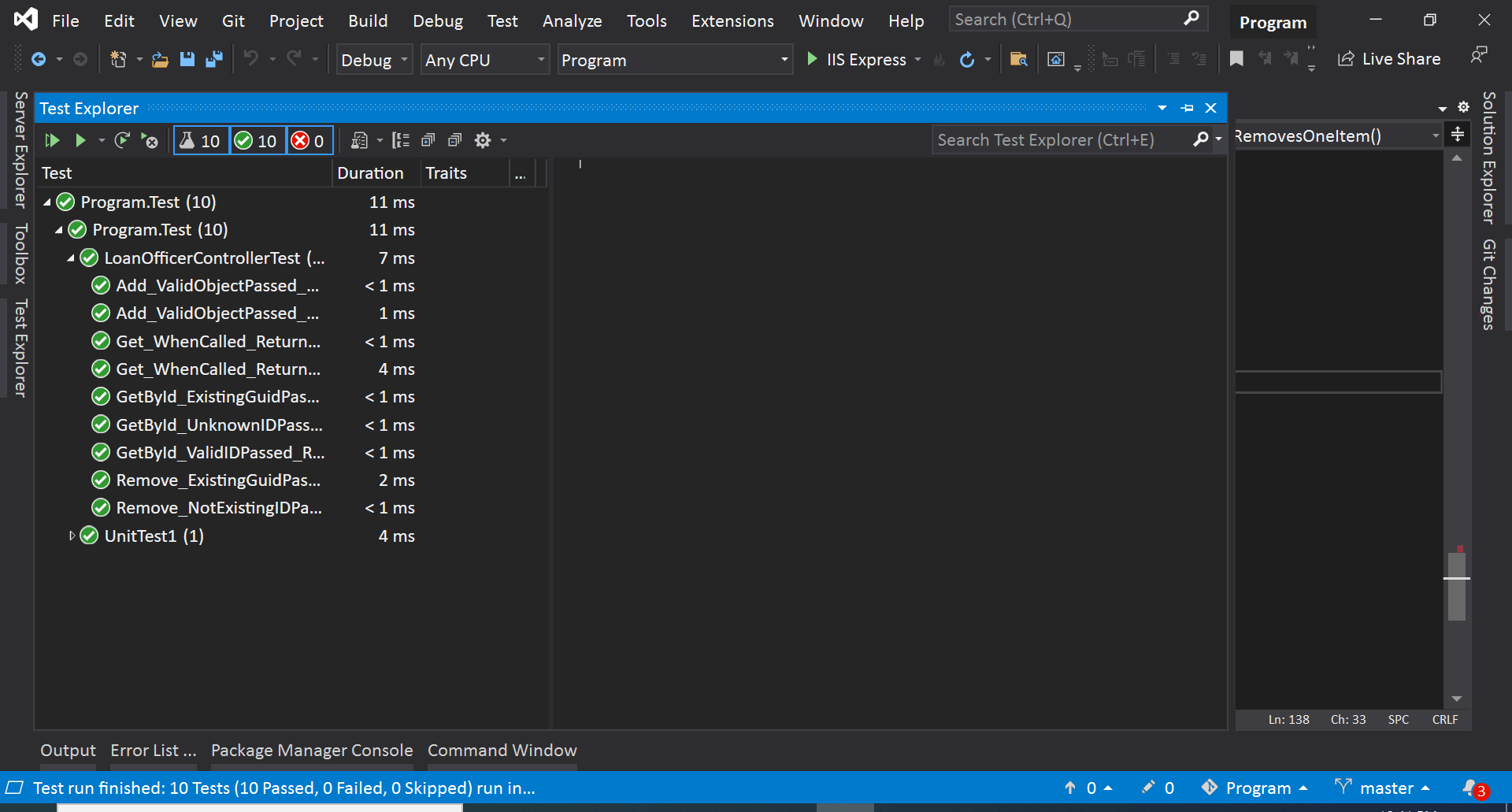

Now we are going to add test script on Jenkins pipeline. The plan was to write the script such a way that whenever any test cases fail, Jenkins pipeline will stop the build.

# Test Automation

## Step 1: Update YAML File

1. Open program-deployment-service.yaml file from dotnet application.
2. Replace with below code.

apiVersion: apps/v1

kind: Deployment

metadata:

labels:

app: amsl-program-api

name: amsl-program-api

spec:

replicas: 3

selector:

matchLabels:

app: amsl-program-api

strategy: {}

template:

metadata:

creationTimestamp: null

labels:

app: amsl-program-api

spec:

affinity:

nodeAffinity:

requiredDuringSchedulingIgnoredDuringExecution:

nodeSelectorTerms:

- matchExpressions:

- key: env

operator: In

values:

- prod

- dev

terminationGracePeriodSeconds: 31

containers:

- image: docker.io/maidulshawon/asai-program-api:TAG_NUMBER

imagePullPolicy: Always

name: program-api-container

ports:

- containerPort: 44339

resources: {}

status: {}

---

apiVersion: v1

kind: Service

metadata:

labels:

app: amsl-program-api

name: amsl-program-api

spec:

type: LoadBalancer

externalIPs:

- 192.168.0.15

ports:

- port: 80

protocol: TCP

targetPort: 44339

selector:

app: amsl-program-api

status:

loadBalancer: {}

On above yaml file, I have added TerminationGracePeriodSeconds and changed image Tag number to a string TAG_NUMBER. We are going to modify TAG_NUMBER value with Jenkins build number and this process going to help if we need to use any old build image.

## Step 2: Update Jenkins Pipeline script

1. Now go back to inside Genkins> ASAI-Program-API>Configure>Pipeline and Update the script with following.

node {

stage("Git Clone")

{

git credentialsId: 'GIT_HUB_CREDENTIALS', url: 'https://github.com/Maidul-Islam-Shawon/ASAI-Program.git', branch: 'master'

}

stage('Restore PACKAGES')

{

sh 'dotnet restore'

}

stage('Clean')

{

sh 'dotnet clean'

}

stage('Unit Test')

{

sh 'dotnet test'

}

stage('Build')

{

sh 'dotnet build --configuration Release'

}

stage("Docker build"){

sh 'docker version'

sh 'docker image build -t asai-program-api .'

sh 'docker image list'

sh 'docker tag asai-program-api maidulshawon/asai-program-api:$BUILD_NUMBER'

}

stage("Docker Login"){

withCredentials([string(credentialsId: 'DOCKER_HUB_PASSWORD', variable: 'PASSWORD')]) {

sh 'docker login -u maidulshawon -p $PASSWORD'

}

}

stage("Push Image to Docker Hub"){

sh 'docker push maidulshawon/asai-program-api:$BUILD_NUMBER'

}

stage("SSH Into AMSL-Master node") {

def remote = [:]

remote.name = 'amsl-master'

remote.host = '192.168.254.10'

remote.user = 'master'

remote.password = 'password'

remote.allowAnyHosts = true

stage('Delete program-deployment-service.yaml file') {

sshCommand remote: remote, command: "echo password | sudo -S rm program-deployment-service.yaml"

}

stage('Copy program-deployment-service.yaml onto amsl-master') {

sshPut remote: remote, from: 'program-deployment-service.yaml', into: '.'

}

stage('Update Image Tag') {

sshCommand remote: remote, command: "sed -ie s/TAG_NUMBER/$BUILD_NUMBER/g program-deployment-service.yaml"

}

stage('Deploy Dotnet API') {

sshCommand remote: remote, command: "kubectl apply -f program-deployment-service.yaml"

}

}

}

As you can see that I did some changes on above script. On ‘Docker Build’ stage, I have modified docker tag number to $BUILD_NUMBER' and keeping all old images. On every build, tag number keeps changing on stage ‘Update Image Tag’ section

I have also added a stage for unit test and this stage scripted such a way that if any test cases fail, Jenkins will stop building the process.

Output report can be check on console output section.

1. Apply and Save.
2. Now change something on the application and push into GIT and wait to start automatic Jenkins Build. You will see output like below if application Test cases and build succeeded successfully.

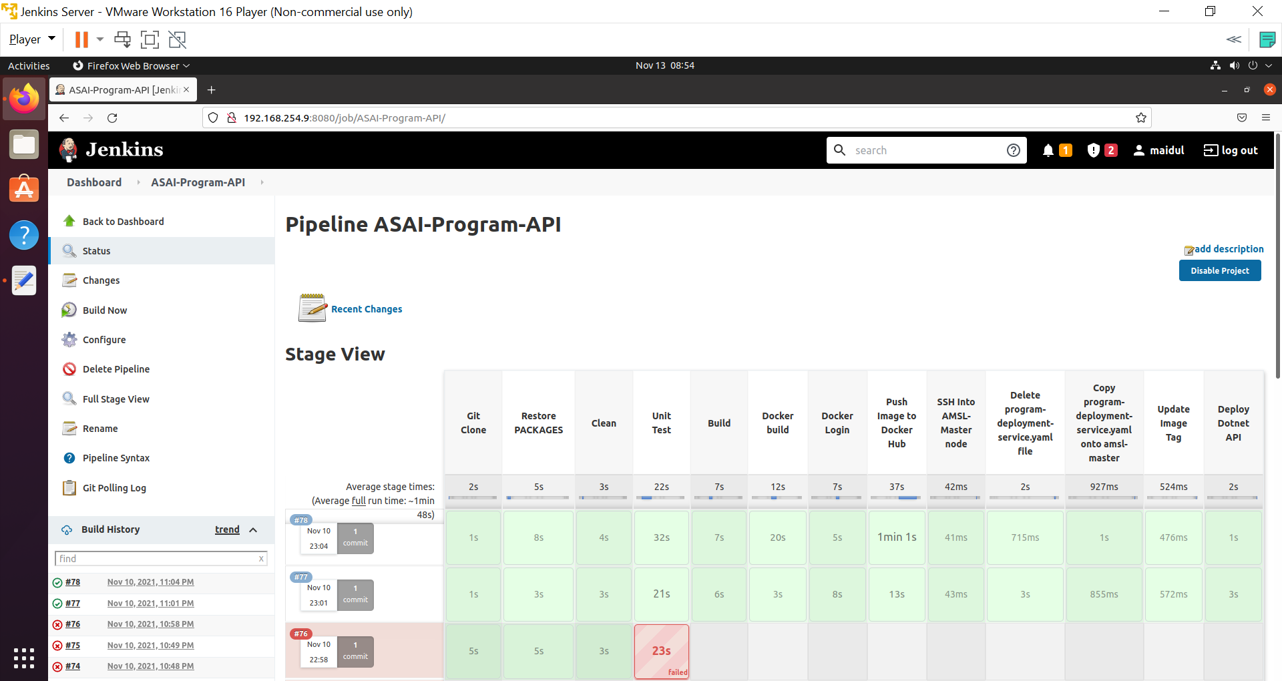

# Conclusion

We have built the application with test cases. Jenkins build will be succeeded only if test cases and application build succeeded. If any of the stages of Jenkins pipeline fail, build will stop automatically. Fail or success report can be check on console output.

# References

<https://www.jenkins.io/>

<https://codefresh.io/kubernetes-tutorial/create-demand-kubernetes-clusters-ci-cd-kind-codefresh/>

<https://www.magalix.com/blog/create-a-ci/cd-pipeline-with-kubernetes-and-jenkins>

<https://platform9.com/blog/create-an-immutable-kubernetes-environment-for-your-ci-cd-pipeline/>

<https://dzone.com/articles/blog-how-to-setup-a-cicd-pipeline-with-kubernetes>

<https://www.tutorialspoint.com/jenkins/jenkins_setup_build_jobs.htm>

<https://kubernetes.io/docs/reference/>

<https://docs.microsoft.com/en-us/dotnet/core/install/linux-ubuntu#2110->

<https://xunit.net/>